CAREER CONNECT LESOTHO

Author : Bafokeng Khoali

Contents
SMART WATER METERING SYSTEM 1
Introduction 4
Background 4
Problem statement 5
Aims and Objectives 6
Goals 7
Objectives 8
Project Scope and Constraints 9
Feasibility Study 9
Justification or Significance of the research 15
Literature review of the project 16
Project Plan and Scheduling 22
Project Plan 22
. Project Scheduling 22
2.1 Initiation Phase (1 Month) 22
2.3 Execution Phase (8 Months) 24
2.4 Closure Phase (1 Month) 26
3. Key Milestones 27
Literature Review 30
Introduction 30
Overview of Smart Metering in Utility Management 30
Existing solutions 32
Current developments 32
Methods and Technologies being used to develop current systems 35
Benefits of Smart Water Metering 37
Problems Facing Smart Water Metering Systems 39
Areas in which existing systems are being used 40
Technologies and methods to use for developing the system 45
Conclusion 46
SYSTEM ANALYSIS AND DESIGN 47
Introduction 47
Methodology 48
System Functional and Non-Functional Requirements 53
System Functionality 58
Identifying Classes/Objects 62
Software development life cycle process adopted 68
System Behaviour 71
Systems Architecture 76
Database Design 77
System Hardware Architecture 84
Interface Design 85
References 87

Introduction

Youth unemployment and skills mismatch remain critical challenges in Lesotho, with thousands of young graduates entering the job market annually without adequate pathways to meaningful employment. Educational institutions produce graduates, companies seek talent, and young people search for opportunities, yet these three pillars operate in isolation without effective coordination. Career Connect Lesotho emerges as a comprehensive digital ecosystem designed to bridge this gap by creating an integrated platform that connects students, educational institutions, companies, and government agencies.
The platform leverages modern technology, including artificial intelligence and machine learning, to facilitate intelligent matching between job seekers and employers, provide career guidance, enable skills development tracking, and generate meaningful analytics for policymakers. By creating a centralized hub for career development, Career Connect Lesotho aims to transform the employment landscape and contribute to economic growth and social development in the Kingdom of Lesotho.

Background
Lesotho faces significant challenges in its youth employment sector. According to recent labour statistics, youth unemployment rates remain persistently high, with many young people struggling to transition from education to employment. Several factors contribute to this situation:
Fragmented Information Systems: Currently, there is no centralized platform where job seekers can find opportunities, employers can post vacancies, and educational institutions can track graduate outcomes. Information about jobs, internships, and training opportunities is scattered across newspapers, social media, word-of-mouth, and informal networks.
Skills Mismatch: Employers frequently report that graduates lack the skills required in the workplace. Educational institutions have limited visibility into industry needs, making it difficult to align curricula with market demands. Students lack awareness of which skills to develop for specific career paths.
Limited Career Guidance: Most students complete their education without access to professional career counselling. They make decisions about fields of study, course selections, and career paths based on limited information, often leading to suboptimal outcomes.
Inefficient Recruitment Processes: Companies rely on manual application processing, newspaper advertisements, and informal networks to find candidates. These methods are time-consuming, expensive, and often fail to reach qualified candidates, particularly those in rural areas.
Lack of Data for Policy Making: Government agencies responsible for employment, education, and economic development operate without comprehensive data on labour market trends, skills gaps, and employment outcomes. This limits their ability to design effective interventions and allocate resources efficiently.
Career Connect Lesotho addresses these challenges by creating a unified digital ecosystem that serves all stakeholders in the employment value chain.

Problem statement
The current state of career connectivity in Lesotho is characterized by fragmentation, inefficiency, and missed opportunities. The following specific problems have been identified:
For Students and Job Seekers:
Students graduate without clear visibility into available job opportunities or the skills required for their desired careers. They submit applications through multiple channels with no way to track their progress. Many miss application deadlines because information is not centralized. Those in rural areas face additional barriers as opportunities are concentrated in urban centres and information does not reach them effectively.
Students cannot easily showcase their skills, projects, and achievements to potential employers. Their academic records remain locked within institutional systems, and they have no portable, verifiable digital identity that follows them throughout their career journey.
For Employers and Companies:
Companies struggle to find qualified candidates, often receiving hundreds of paper applications that must be manually sorted and reviewed. The screening process is time-consuming and subjective, leading to suboptimal hiring decisions. Small and medium enterprises cannot afford expensive recruitment agencies and rely on limited networks.
Employers have no mechanism to build relationships with educational institutions or to provide input on curriculum development. They cannot track the performance of graduates they hire or provide feedback to institutions.
For Educational Institutions:
Institutions lack data on graduate employment outcomes, making it difficult to assess program effectiveness or demonstrate value to prospective students and funders. They cannot track alumni career trajectories or engage alumni as mentors for current students.
Career development offices operate with limited resources and outdated tools. They struggle to connect students with employers and to provide meaningful career guidance.
For Government and Policymakers:
The Ministry of Education and Training, Ministry of Employment and Labour, and other government agencies lack comprehensive data on labour market dynamics. They cannot accurately measure unemployment rates by demographic group, identify skills gaps, or evaluate the effectiveness of training programs.
Policy decisions are made based on incomplete information, leading to interventions that may not address root causes or achieve desired outcomes.
For the Economy and Society:
The cumulative effect of these problems is a labour market that operates below its potential. Young people remain unemployed or underemployed despite available opportunities. Employers cannot fill positions, constraining business growth. The economy loses the productive contribution of thousands of young people, perpetuating cycles of poverty and limiting national development.

Aims and Objectives
Career Connect Lesotho aims to transform the employment landscape by creating an integrated digital ecosystem that connects students, educational institutions, employers, and government agencies. The platform will leverage modern technology to facilitate efficient matching, provide actionable insights, and enable data-driven decision-making.

4.1 Goals

Goal 1: Create a Unified Career Ecosystem
Establish a single, comprehensive platform that serves all stakeholders in the employment value chain, eliminating fragmentation and creating seamless connections between students, institutions, employers, and government.
Goal 2: Enable Intelligent Matching
Implement artificial intelligence and machine learning algorithms that match job seekers with opportunities based on skills, interests, and potential, while helping employers identify the best candidates efficiently.
Goal 3: Provide Data-Driven Insights
Generate comprehensive analytics and reports that enable educational institutions to align curricula with market needs, employers to understand talent availability, and government to design effective policies.
Goal 4: Enhance Career Development
Empower students with tools and resources for career planning, skills development, and professional growth, including mentorship connections, learning resources, and career guidance.
Goal 5: Foster Sustainable Economic Growth
Contribute to Lesotho's economic development by reducing youth unemployment, improving labour market efficiency, and ensuring that the country's human capital is developed and utilized effectively.

4.2 Objectives
Objective 1: Develop Core Platform Infrastructure
1.1 Design and implement a scalable, secure web and mobile platform that supports user registration, profile management, and role-based access for students, companies, institutions, and administrators.
1.2 Create a centralized database structure that stores user profiles, job postings, applications, educational records, and interaction data with appropriate privacy controls and data protection measures.
1.3 Deploy cloud infrastructure that ensures high availability, performance, and scalability as user numbers grow.
Objective 2: Implement Job and Opportunity Posting System
2.1 Develop a comprehensive job posting system that allows employers to create detailed job descriptions, specify required skills and qualifications, and manage applications.
2.2 Create internship and apprenticeship posting functionality with support for program duration, supervision requirements, and learning outcomes.
2.3 Implement application tracking that allows candidates to monitor their application status and employers to manage their hiring pipeline efficiently.
Objective 3: Build AI-Powered Matching Engine
3.1 Develop machine learning models that analyse student profiles, skills, and preferences to recommend relevant job opportunities.
3.2 Create employer-facing tools that identify top candidates based on job requirements and historical hiring success patterns.
3.3 Implement continuous learning mechanisms that improve matching accuracy based on user interactions and outcomes.
Objective 4: Create Analytics and Reporting Dashboard
4.1 Design comprehensive analytics dashboards for students (personal progress), companies (hiring metrics), institutions (graduate outcomes), and government (labour market trends).
4.2 Implement real-time data visualization that makes complex information accessible and actionable.
4.3 Develop export and reporting tools that allow stakeholders to generate custom reports for internal use or regulatory requirements.
Objective 5: Establish Mentorship and Networking Features
5.1 Create a mentorship matching system that connects students with experienced professionals based on career interests, industry, and development goals.
5.2 Implement messaging and communication tools that facilitate meaningful connections while maintaining appropriate boundaries and safety measures.
5.3 Develop community features including discussion forums, professional groups, and event management for webinars and networking events.
Objective 6: Integrate Skills Assessment and Development Tools
6.1 Implement skills assessment tools that help students identify their strengths, gaps, and development priorities.
6.2 Integrate with online learning platforms to recommend courses and resources for skill development.
6.3 Create digital credentialing and badging that allows students to showcase verified skills and achievements.
Objective 7: Ensure Robust Security and Data Protection
7.1 Implement comprehensive authentication and authorization controls including multi-factor authentication for sensitive operations.
7.2 Ensure compliance with Lesotho's data protection laws and international best practices for handling personal information.
7.3 Conduct regular security audits and penetration testing to identify and address vulnerabilities.
Objective 8: Deploy Mobile Applications for Accessibility
8.1 Develop native mobile applications for iOS and Android that provide core functionality optimized for mobile devices.
8.2 Ensure offline capabilities for users in areas with limited internet connectivity.
8.3 Implement push notifications for important updates, application deadlines, and new opportunities.

Project Scope and Constraints
Career Connect Lesotho will be developed and deployed as a comprehensive digital ecosystem with the following scope:
In Scope:
- Development of web-based platform accessible via modern browsers
- Native mobile applications for iOS and Android devices
- User registration and profile management for students, companies, institutions, and administrators
- Job and internship posting and application management
- AI-powered matching between candidates and opportunities
- Mentorship program management and communication tools
- Analytics dashboards for all user types
- Integration with educational institutions for verification of academic records
- Skills assessment and development planning tools
- Notification system (email, SMS, push)
- Administrative interface for platform management
- API infrastructure for future integrations
- Comprehensive security and data protection measures
- User training and documentation
- Pilot deployment with select institutions and companies
- Full national rollout following pilot success
Out of Scope:
- Physical career counselling services (platform provides tools but not in-person services)
- Direct placement guarantees (platform facilitates connections but does not guarantee employment)
- Financial transactions beyond basic payments (future phases may include payment processing)
- Integration with international job markets (focus on Lesotho initially)
- Hardware provision for users (users require their own devices)
- Internet connectivity provision (users responsible for their own connectivity)
- Curriculum development or delivery (platform recommends but does not create educational content)
- Accreditation or certification services (platform verifies but does not grant credentials)
Constraints
Time Constraints:
The project must be completed within twelve months from initiation to full deployment, with specific milestones:
- Month 3: Core platform functional for pilot testing
- Month 6: Pilot deployment with 5 institutions and 20 companies
- Month 9: Mobile applications ready for testing
- Month 12: Full national deployment
Budget Constraints:
The project operates within a defined budget that covers:
- Development team salaries and overhead
- Cloud infrastructure and hosting costs
- Third-party service integrations
- Training and documentation
- Marketing and user acquisition
- Ongoing maintenance and support for first year
Technical Constraints:
- Must integrate with existing institutional systems where possible
- Must function reliably on lower-end mobile devices and limited bandwidth
- Must comply with Lesotho's data protection regulations
- Must scale to support national user base
- Must maintain high availability with minimal downtime
Resource Constraints:
- Development team size limited to core technical staff plus specialists
- Reliance on existing institutional data systems that may have varying quality and accessibility
- Limited availability of training data for AI models initially
- Dependence on stakeholder cooperation for data sharing and integration
Regulatory Constraints:
- Must comply with data protection and privacy laws
- Must meet government requirements for accessibility and inclusivity
- Must ensure appropriate safeguards for minor users (students under 18)
- Must maintain audit trails for regulatory compliance
Operational Constraints:
- Users have varying levels of digital literacy requiring intuitive design
- Internet connectivity varies significantly across the country requiring offline capabilities
- Multiple languages (English and Sesotho) must be supported
- Cultural considerations affect design and communication approaches

Feasibility Study
A comprehensive feasibility study has been conducted to assess the viability of the Career Connect Lesotho platform across operational, technical, social, legal, and economic dimensions.

Operational feasibility
Operational feasibility examines whether the platform can be effectively implemented and sustained within the existing operational environment of Lesotho's education and employment sectors.
Key Operational Requirements:
- Skilled personnel for development and ongoing maintenance
- Reliable internet connectivity for platform access
- Compatible devices for end users (smartphones, computers)
- Institutional cooperation for data sharing and verification
- User adoption and engagement across stakeholder groups
- Ongoing support and training mechanisms
Assessment:
The project demonstrates strong operational feasibility. Lesotho has a growing pool of ICT professionals capable of developing and maintaining the platform. Mobile penetration is high, with most young people owning smartphones. Internet connectivity, while variable, is sufficient for the platform's core functions, and offline capabilities will address connectivity gaps.
Educational institutions have expressed willingness to participate, recognizing the value of better graduate outcome tracking. Companies are eager for more efficient recruitment channels. The government has identified youth employment as a priority and supports initiatives that address this challenge.
Operational challenges include varying levels of digital literacy, particularly among older users and those in rural areas. The platform addresses this through intuitive design, multi-language support, and comprehensive training materials. Ongoing user support will be provided through multiple channels including help desk, documentation, and in-person training sessions.
The project is operationally feasible with appropriate attention to user training, support infrastructure, and phased rollout that allows for learning and adjustment.

Technical feasibility
Technical feasibility assesses whether the proposed platform can be built with available technology and technical expertise.
Technical Requirements:
- Modern web development frameworks (React, Node.js)
- Scalable cloud infrastructure (AWS, Google Cloud, or Azure)
- Mobile application development for iOS and Android
- Machine learning and AI capabilities for matching algorithms
- Database systems for structured and unstructured data
- API integrations with institutional systems
- Security and encryption technologies
- Real-time communication tools
Assessment:
The required technologies are mature, well-documented, and widely used in similar applications globally. The development team has expertise in the necessary frameworks and tools. Cloud infrastructure providers offer services in or near the region, ensuring acceptable performance.
Machine learning models for matching will require training data. Initial models will be developed using available data and improved through continuous learning as user interactions generate more data. Transfer learning from similar platforms in other markets can accelerate model development.
Mobile applications will be developed using cross-platform frameworks to maximize code reuse while maintaining native performance and user experience. Progressive web app capabilities will provide mobile web access for users who cannot or prefer not to install native apps.
Security measures including encryption, access controls, and audit logging will be implemented from the start. Regular security assessments will identify and address vulnerabilities.
The project is technically feasible with current technology and available expertise.

Social Feasibility
Social feasibility examines the platform's alignment with social values, community needs, and stakeholder acceptance.
Social Requirements:
- User acceptance across diverse demographic groups
- Equity of access regardless of location or socioeconomic status
- Empowerment of young people in their career development
- Ethical use of data and protection of privacy
- Cultural appropriateness in design and communication
- Positive impact on communities and society
Assessment:
Career Connect Lesotho addresses fundamental social needs including youth employment, educational relevance, and economic opportunity. Stakeholders across all groups have expressed strong support for the concept.
The platform promotes equity by making opportunities visible to all, regardless of location or social connections. Students in rural areas gain access to the same information as those in urban centres. Transparent application processes reduce the influence of personal networks in hiring decisions.
Privacy and data protection are paramount. The platform will implement strict access controls, obtain explicit consent for data use, and provide users with control over their information. Educational campaigns will help users understand their rights and make informed decisions about data sharing.
Cultural considerations are integrated into design, including language options, culturally appropriate imagery, and sensitivity to local norms around communication and relationships between students and professionals.
The project demonstrates strong social feasibility and aligns with community values and aspirations.

Legal Feasibility
Legal feasibility assesses compliance with relevant laws, regulations, and legal requirements in Lesotho.
Legal Requirements:
Data Protection and Privacy: The platform must comply with Lesotho's Data Protection Act, which governs the collection, storage, and processing of personal information. This includes requirements for consent, data minimization, security measures, and rights of access and correction.
Consumer Protection: The platform must provide accurate information about services, transparent terms of use, and fair treatment of users. Misrepresentation of opportunities or misleading users about employment prospects could violate consumer protection laws.
Labour and Employment Laws: Job postings must comply with labour laws regarding non-discrimination, minimum wage, working conditions, and other employment standards. The platform must not facilitate illegal employment practices.
Education Sector Regulations: Integration with educational institutions must comply with regulations governing academic records, student privacy, and institutional data sharing.
Telecommunications and Digital Commerce: The platform's operation over telecommunications networks must comply with relevant regulations, particularly regarding data transmission and security.
Cybersecurity Requirements: The platform must implement appropriate security measures to protect against unauthorized access, data breaches, and cyber threats, in accordance with any applicable cybersecurity regulations or standards.
Assessment:
The project has been reviewed against Lesotho's legal framework. All identified legal requirements can be met through appropriate platform design, policies, and procedures. Key measures include:
- Privacy policy and terms of use that clearly communicate data practices
- Consent mechanisms for data collection and use
- Role-based access controls limiting data access to authorized personnel
- Encryption of sensitive data in transit and at rest
- Audit logging for compliance monitoring
- Regular legal review as regulations evolve
The project is legally feasible with appropriate attention to compliance requirements.

Economic Feasibility
Economic feasibility evaluates whether the platform's benefits justify its costs and whether it can be sustained financially.
Economic Requirements:
- Initial development and deployment funding
- Ongoing operational and maintenance costs
- Demonstrable value to stakeholders justifying continued investment
- Potential revenue streams for sustainability
- Economic benefits to users and society
Cost Analysis:
Initial development costs include:
- Software development and engineering
- Cloud infrastructure setup
- Third-party service integrations
- Training and documentation
- Initial marketing and user acquisition
Ongoing operational costs include:
- Cloud hosting and infrastructure
- Technical support and maintenance
- Staff salaries
- Continuous improvement and feature development
- User support and training
Benefit Analysis:
Benefits to students include:
- Access to more job opportunities
- Reduced time and cost in job searching
- Better matches leading to improved career outcomes
- Access to mentorship and career guidance
- Portable digital credentials and verified skills
Benefits to employers include:
- Reduced recruitment costs and time
- Access to larger, more qualified candidate pools
- Better hiring decisions through data and analytics
- Improved employer branding and visibility
- Connections with educational institutions
Benefits to institutions include:
- Better tracking of graduate outcomes
- Improved ability to demonstrate program effectiveness
- Enhanced career services for students
- Stronger relationships with employers
- Data for curriculum improvement
Benefits to government include:
- Comprehensive labour market data for policy making
- More effective employment programs
- Reduced youth unemployment and associated social costs
- Improved economic productivity and growth
- Better allocation of education and training resources
Sustainability Model:
The platform will be sustained through a combination of:
- Government funding as a national development initiative
- Institutional membership fees for enhanced services
- Employer subscriptions for premium recruitment features
- International development partner support
- Advertising and sponsored content (with appropriate safeguards)
Return on Investment:
Preliminary analysis indicates positive return on investment within three years based on:
- Reduced unemployment-related social services costs
- Increased tax revenues from employed youth
- Improved productivity from better job matching
- Reduced recruitment costs for employers
- More efficient use of education and training resources
The project is economically feasible with appropriate funding and sustainability planning.

Justification or Significance of the research
Career Connect Lesotho represents a transformative intervention in the country's education-to-employment ecosystem. Its significance extends across multiple dimensions:
For Individual Empowerment:
The platform empowers young people to take control of their career development. Students gain visibility into opportunities, understand the skills they need to develop, and can track their progress toward employment. This agency is particularly important for young women, rural youth, and others who may face additional barriers in traditional job search channels.
For Educational Transformation:
By providing institutions with data on graduate outcomes and employer needs, the platform enables evidence-based curriculum development. Education becomes more relevant to labour market demands, improving the value proposition for students and funders alike. Career services are enhanced with better tools and connections.
For Economic Development:
Efficient labour markets are fundamental to economic growth. By reducing friction in the job matching process, Career Connect Lesotho helps ensure that human capital is deployed where it can be most productive. Employers can fill positions faster, businesses can grow, and the economy benefits from increased output and innovation.
For Social Cohesion:
Youth unemployment is associated with social instability, crime, and emigration. By creating pathways to meaningful employment, the platform contributes to social stability and gives young people reason to remain in Lesotho and contribute to national development. The platform also promotes equity by making opportunities visible to all, regardless of background or connections.
For Policy and Planning:
Government agencies gain unprecedented visibility into labour market dynamics. For the first time, policymakers can see which sectors are growing, which skills are in demand, and which groups face the greatest employment challenges. This evidence base enables more effective interventions and better allocation of limited resources.
For International Competitiveness:
As Lesotho integrates further into regional and global economies, having a skilled, employable workforce becomes increasingly important. Career Connect Lesotho helps ensure that the country's human capital meets international standards and that young people can compete for opportunities beyond national borders.
For Innovation and Entrepreneurship:
The platform's data and analytics capabilities can identify emerging opportunities and gaps in the market. Entrepreneurs can use this information to start businesses that address unmet needs. Investors gain better information about which sectors offer the greatest potential.
For Future Generations:
Perhaps most significantly, Career Connect Lesotho creates infrastructure that will benefit generations of young people to come. Once established, the platform becomes a permanent part of the country's education and employment ecosystem, continuously improving through data accumulation and system enhancement.

Literature review of the project
Digital career platforms have emerged globally as powerful tools for addressing labour market inefficiencies. While such platforms are well-established in developed economies, their adoption in emerging markets, particularly in Africa, is accelerating rapidly.
Global Context
Platforms like LinkedIn, Indeed, and Glassdoor have transformed how people find jobs and how companies recruit in developed economies. These platforms aggregate opportunities, provide professional networking, and offer insights into companies and careers. However, their models assume certain infrastructure and user characteristics that may not hold in emerging markets.
African Landscape
Across Africa, numerous platforms have emerged to address local needs:
Jobberman (Nigeria, Ghana): One of West Africa's largest job platforms, connecting millions of job seekers with employers. It offers CV writing services, job alerts, and employer branding solutions.
BrighterMonday (Kenya, Uganda, Tanzania, Zambia): A comprehensive career platform serving East Africa with job postings, career advice, and recruitment services for employers.
Fuzu (Kenya, Nigeria, Uganda): A career development platform that goes beyond job listings to include personalized recommendations, career coaching, and skills assessments.
SendCV (South Africa): A platform focused on matching skilled professionals with opportunities across Africa.
Kaleta (Multiple countries): A mobile-first platform targeting young African professionals with job listings and career content.
Lessons from Existing Platforms
Analysis of existing platforms reveals several key lessons for Career Connect Lesotho:
Mobile-First is Essential: In markets where smartphone penetration exceeds computer access, mobile-first or mobile-only approaches are necessary. Users expect to search for jobs, upload CVs, and apply through their phones.
Trust and Verification Matter: Fraudulent job postings and misrepresentation are significant concerns. Platforms that implement verification mechanisms for employers and provide ways to validate job legitimacy build greater trust.
Localization is Critical: Language, cultural norms, and local employment practices must be reflected in platform design. What works in Nigeria may not work in Lesotho.
Skills Development Integration: Successful platforms recognize that many job seekers need support in developing employability skills. Integration with learning resources and skills assessments adds significant value.
Data for Decision Making: Platforms that provide analytics to governments, institutions, and employers create additional value and stakeholder engagement.
Sustainability Requires Multiple Revenue Streams: Reliance on any single revenue source creates vulnerability. Successful platforms diversify through employer subscriptions, advertising, premium user features, and institutional partnerships.
Partnerships Enhance Reach: Collaboration with telecommunications companies, educational institutions, and government agencies accelerates user acquisition and adds credibility.
Continuous Innovation is Necessary: Technology and user expectations evolve rapidly. Platforms must continuously improve features, user experience, and matching algorithms to remain relevant.
Positioning Career Connect Lesotho
Career Connect Lesotho will build on lessons from existing platforms while addressing the specific context of Lesotho. Key differentiators include:
Comprehensive Ecosystem Approach: Rather than focusing solely on job listings, the platform integrates education, skills development, mentorship, and analytics into a unified ecosystem.
Government Integration: Close collaboration with government agencies ensures alignment with national priorities and provides data for policy making.
AI-Powered Matching: Advanced machine learning algorithms will provide personalized recommendations that improve over time based on user interactions and outcomes.
Offline Capabilities: Recognizing connectivity challenges, the platform will function effectively even with intermittent internet access.
Multi-Language Support: Full support for Sesotho and English ensures accessibility across population segments.
Institutional Integration: Direct integration with educational institutions enables verification of academic credentials and tracking of graduate outcomes.

Project Plan and Scheduling

9.1Project Plan

9.1.1 Project Title:
Career Connect Lesotho - National Career Ecosystem Platform

1.1.2 Project Manager:
Bafokeng Khoali

1.1.3 Project Timeline:
12 Months

1.1.4 Project Phases:
The project will be divided into 4 key phases: Initiation, Planning, Execution, closure.

9.2 Project Scheduling

9.2.1 Initiation Phase (1 Month)
Goal: Define project objectives, assess feasibility, and engage stakeholders.
Activity | Duration | Dependencies
Project Kick-off Meeting | Week 1 | None
Define Project Objectives & Scope | Weeks 1-2 | None
Feasibility Study | Weeks 2-3 | None
Identify Stakeholders and Gather Initial Requirements | Weeks 2-3 | Feasibility Study
Stakeholder Engagement Workshops | Weeks 3-4 | Stakeholder Identification
Project Charter Development | Week 4 | All previous activities

2.2 Planning Phase (2 Months)
Goal: Develop detailed project plan, schedules, risk management strategies, and resource allocation.
Activity | Duration | Dependencies
Detailed Project Plan Creation | Weeks 5-6 | Project Charter
Budget Estimation and Approval | Weeks 5-6 | Project Charter
Resource Allocation | Weeks 5-6 | Charter Approval
Risk Management Plan | Weeks 5-7 | Project Plan
System Requirements Gathering | Weeks 6-7 | Project Charter
Technical Architecture Design | Weeks 6-8 | Requirements
Database Schema Design | Weeks 7-8 | Architecture
UI/UX Design and Prototyping | Weeks 7-9 | Requirements
Technology Stack Finalization | Week 8 | Architecture
Project Timeline and Scheduling | Weeks 6-8 | Project Plan
Stakeholder Review and Approval | Week 8 | All planning activities

9.2.2 Execution Phase (8 Months)
Goal: Development, testing, and implementation of the Career Connect Lesotho platform.
A. System Design and Architecture (1.5 Months)
Activity | Duration | Dependencies
System Architecture Finalization | Weeks 9-10 | Planning Phase
Database Implementation | Weeks 9-11 | Schema Design
API Design and Documentation | Weeks 9-11 | Architecture
Security Architecture Design | Weeks 10-12 | Architecture
Cloud Infrastructure Setup | Weeks 10-12 | Architecture
Mobile App Architecture Design | Weeks 11-13 | Architecture
Design Review and Approval | Week 13 | All design activities
.
B. Core Platform Development (3 Months)
Module / Feature | Duration |  | Dependencies / Prerequisites
User Authentication System |  | Weeks 14–15 | Database setup, API design
User Profile Management |  | Weeks 14–16 | Authentication system
Job Posting & Management |  | Weeks 15–17 | Profile management system
Application Management System |  | Weeks 16–18 | Job posting system
Search & Filter Functionality |  | Weeks 16–18 | All core modules operational
Administrative Interface |  | Weeks 17–19 | All core modules operational
Notification System |  | Weeks 17–19 | All core modules operational
Integration with Institutional Systems |  | Weeks 18–20 | Completed API design
API Development (Full System) |  | Weeks 14–20 | All core modules

C. AI and Machine Learning Development (2 Months, parallel with Core Development)
Module / Activity | Duration | Dependencies / Prerequisites
Data Collection & Preparation | Weeks 14–16 | Database availability
Matching Algorithm Development | Weeks 16–18 | Completed data preparation
Recommendation Engine | Weeks 17–19 | Matching algorithms
Analytics Engine | Weeks 18–20 | All machine learning components
Model Training & Validation | Weeks 19–21 | All machine learning components
AI System Integration | Weeks 20–22 | Core platform readiness

9.2.3 Closure Phase (1 Month)
Activity | Duration | Dependencies / Prerequisites
Full National Launch | Week 28 | All development and testing complete
Post-Launch Monitoring | Weeks 28–30 | System launch
Project Review Meeting | Week 29 | Launch completed
System Documentation Handover | Weeks 29–30 | Documentation finalized
Training Completion | Weeks 29–30 | Training materials prepared
Final Budget Report | Week 30 | Project closure process
Lessons Learned Documentation | Week 30 | Project review completed
Project Completion Report | Week 31 | All closure activities
Transition to Operations Team | Week 31 | Completion report approved

9.2.4. Key Milestones
Milestone | Target Week
Project Kick-off | Week 1
Project Charter Approved | Week 4
Requirements Finalized | Week 8
Design Phase Complete | Week 13
Core Platform Development Complete | Week 20
Mobile Apps Ready for Testing | Week 21
AI System Integration Complete | Week 22
Pilot Launch | Week 23
Testing Complete | Week 24
Pilot Evaluation Complete | Week 26
Full National Launch | Week 28
Project Closure | Week 31

Platform Analysis and Review

Introduction
A comprehensive review of existing career platforms, relevant technologies, and implementation approaches provides the foundation for developing Career Connect Lesotho. This section synthesizes findings from global and regional platforms, identifies best practices, and establishes the technological and methodological framework for the project.
Overview of Digital Career Platforms in Emerging Markets
Digital career platforms have evolved significantly over the past decade, transitioning from simple job boards to sophisticated ecosystems that address multiple aspects of the employment lifecycle. In emerging markets, these platforms face unique challenges and opportunities:

- Infrastructure Constraints: Limited and unreliable internet connectivity, particularly in rural areas, requires platforms to function effectively with intermittent access and on lower-end devices.

- Trust Deficit: Users in emerging markets often have legitimate concerns about online scams and fraudulent job postings. Platforms that implement robust verification mechanisms build greater trust.

- Informal Sector Dominance: In many emerging markets, the majority of employment is in the informal sector. Platforms must consider how to serve both formal and informal employment needs.

- Skills Gap: Many job seekers lack the skills required for available positions. Platforms that integrate skills development create additional value.

- Gender and Inclusion: Women and marginalized groups face additional barriers in accessing opportunities. Platforms must be designed to promote rather than hinder inclusion.

- Regulatory Environment: Data protection, labour laws, and other regulations vary significantly across jurisdictions and may be evolving.

Existing solutions
Global Platforms with Regional Presence
- LinkedIn: The world's largest professional network has growing presence in Africa, particularly among professionals in urban centres and multinational companies. However, its model assumes certain levels of digital literacy and professional experience that may not be representative of broader job seekers.
- Indeed: A job aggregation platform with significant reach globally. Its simple, search-based model works well for active job seekers but provides limited support for career development or skills matching.
- Glassdoor: Provides company reviews and salary information that help job seekers make informed decisions. Such transparency is valuable but depends on sufficient user contributions.

Regional African Platforms
leading job platforms. It offers job listings, CV services, and training programs. Key success factors include strong brand recognition, partnerships with employers, adaptation to local context, and acquisition by Ringier Africa, providing resources for expansion. Jobberman's soft skills training program has reached hundreds of thousands of young Nigerians, demonstrating the value of integrating skills development with job matching.
BrighterMonday (Kenya, Uganda, Tanzania, Zambia): Operating across multiple East African countries, BrighterMonday provides job listings, career advice, and recruitment services. The platform has succeeded through localization, strong employer relationships, and investment in mobile user experience. Its blog and career resources provide ongoing value to job seekers beyond job listings.
Fuzu (Kenya, Nigeria, Uganda): Fuzu differentiates itself through personalized career recommendations, skills assessments, and career coaching. The platform's focus on career development rather than just job listings has resonated with users seeking long-term career growth. Fuzu's algorithm learns from user behaviour to improve recommendations over time, creating a personalized experience that keeps users engaged.
SendCV (South Africa): Focuses on matching skilled professionals with opportunities, with strong emphasis on candidate quality and employer needs. The platform uses a curated approach, screening candidates before presenting them to employers, which appeals to companies seeking quality over quantity.
Kaleta (Pan-African): A mobile-first platform targeting young African professionals with job listings and career content. Its mobile focus addresses the reality of how most Africans access the internet, with an application that works well on smartphones and in low-bandwidth conditions.
Kazitoday (Kenya): Focuses on informal sector and casual labour opportunities, recognizing that many Kenyans work in informal arrangements. The platform connects workers with short-term gigs, domestic work, and casual labour, serving a segment often overlooked by traditional job platforms.

Sector-Specific Platforms
Beyond general job platforms, numerous sector-specific platforms have emerged to address unique needs of particular industries:
Healthcare: Platforms like Health eCareers and MedZilla connect healthcare professionals with opportunities in hospitals, clinics, and healthcare organizations. These platforms understand the specific requirements of healthcare recruitment, including licensing, credentials, and specialized skills.
Technology: Platforms like Andela identify and connect African tech talent with global companies, combining skills assessment, training, and placement. GitHub Jobs and Stack Overflow Careers focus specifically on developers, leveraging these platforms' communities and technical credibility.
Agriculture: Platforms like Farmcrowdy and Agrivi connect agricultural workers with farm employment and agribusiness opportunities, sometimes integrating with broader agricultural technology ecosystems that include inputs, financing, and market access.
Education: Platforms like Teach Away and Schrole connect teachers with schools and educational institutions globally, handling the complexities of international certification, visa requirements, and school accreditation.
Creative Industries: Platforms like Behance and Dribbble serve creative professionals, showcasing portfolios alongside job listings. These platforms recognize that for creative roles, demonstrated work is often more important than traditional credentials.

Government and Development Partner Initiatives
Several government and development partner initiatives have attempted to address career connectivity:
- Labour Market Information Systems (LMIS): Many countries have developed LMIS to collect and disseminate labour market data. These systems often focus on macro-level statistics rather than individual job matching, but some have evolved to include job portals and career guidance.
- Youth Employment Programs: Development partners including the World Bank, ILO, and various NGOs have implemented youth employment programs that sometimes include digital platforms for job matching, training, and support services.
- Public Employment Services: Traditional public employment offices in many countries have attempted to digitize their services, with varying degrees of success. Challenges include limited resources, outdated technology, and competition from private sector platforms.

Current Developments
Artificial Intelligence and Machine Learning
AI is transforming how career platforms operate, enabling capabilities that were previously impossible:
Intelligent Matching: Machine learning algorithms analyse candidate profiles, job requirements, and historical success patterns to identify optimal matches. These systems consider multiple factors simultaneously—skills, experience, education, location preferences, salary expectations, and cultural fit—to generate ranked recommendations. The algorithms improve over time as they learn from user interactions and outcomes, becoming more accurate with each match.
Activity | Duration | Dependencies / Prerequisites
Data Collection & Preparation | Weeks 14–16 | Database availability
Matching Algorithm Development | Weeks 16–18 | Data preparation completed
Recommendation Engine Development | Weeks 17–19 | Matching algorithms
Analytics Engine Implementation | Weeks 18–20 | All ML components
Model Training & Validation | Weeks 19–21 | All ML components
AI System Integration | Weeks 20–22 | Core platform readiness

Skills Inference: AI can infer candidate skills from profile information, work history, and even unstructured text such as job descriptions or project summaries. Natural Language Processing techniques identify capabilities that candidates may not have explicitly listed, enriching profiles and improving match quality. For example, a candidate who describes building websites may have skills inferred in HTML, CSS, JavaScript, and project management even if these are not explicitly listed.
Predictive Analytics: Platforms can predict which candidates are most likely to succeed in specific roles, which job seekers are at risk of long-term unemployment, and which employers are most likely to make hires. These predictions enable proactive interventions—career guidance for at-risk job seekers, targeted outreach to promising candidates, and recommendations to employers about where to focus their recruitment efforts.
Natural Language Processing: NLP enables platforms to understand job descriptions, extract key requirements, and match them with candidate profiles more accurately. It can identify synonyms and related terms (e.g., recognizing that "Java" and "JavaScript" are different skills while "Java" and "J2EE" are related). NLP also powers chatbots that provide career guidance, answer user questions, and assist with application processes, reducing the burden on human support staff.
Learning Algorithms: Continuous learning mechanisms allow platforms to improve recommendations based on user behaviour—which jobs users click on, which applications lead to interviews, and which matches result in successful hires. Reinforcement learning techniques optimize for long-term outcomes rather than immediate clicks, prioritizing matches that lead to successful employment.
Bias Detection and Mitigation: AI can be used to detect and mitigate bias in recruitment processes. Algorithms can flag job descriptions with gendered language, identify patterns of discrimination in hiring decisions, and ensure that matching algorithms do not perpetuate historical biases. This promotes fairness and inclusion in the hiring process.

Mobile-First Architecture
With smartphone penetration increasing rapidly across Africa, platforms are adopting mobile-first or mobile-only approaches that recognize how users actually access the internet:
Progressive Web Apps (PWAs): PWAs provide app-like experiences through mobile browsers, eliminating the need for installation while offering offline capabilities, push notifications, and fast performance. Users can access the platform without consuming limited storage space or navigating app store downloads. PWAs work on any device with a modern browser, including lower-end Android phones that dominate many African markets.
Native Applications: For users with capable devices and reliable connectivity, native iOS and Android apps provide optimal performance and access to device features. Cameras can be used for document scanning (uploading CVs, capturing certificates), GPS enables location-based job searches, and push notifications ensure users never miss important updates. Native apps provide the richest user experience but require more development resources and ongoing maintenance.
USSD and SMS Integration: For users with basic phones or unreliable internet, some platforms integrate USSD and SMS channels to provide basic services. Users can receive job alerts via SMS, apply for positions using USSD codes, and access basic career information without requiring smartphones or data plans. This ensures that no one is excluded from the platform's benefits, regardless of their device or connectivity.
Offline Capabilities: Advanced platforms enable users to download content, complete applications, and perform other functions while offline, syncing data when connectivity is restored. This is essential in markets where connectivity is intermittent or expensive, allowing users to maximize their time online and minimize data costs.
Data Optimization: Mobile-first platforms optimize data usage through compression, lazy loading, and efficient caching. Images are compressed, code is minified, and only essential content is loaded initially. This reduces costs for users on metered connections and improves performance in low-bandwidth conditions.

Blockchain for Verification
Emerging platforms are exploring blockchain technology for credential verification, addressing the challenge of fraudulent qualifications:
- Verifiable Credentials: Educational institutions can issue blockchain-anchored credentials that employers can verify instantly without contacting the institution. The blockchain provides a tamper-proof record of the credential's existence and authenticity, while the user controls access to the actual credential data. This eliminates the administrative burden of verification requests and reduces opportunities for fraud.
- Self-Sovereign Identity: Users control their own identity and credentials, sharing only what they choose with potential employers. Rather than relying on platforms to store and protect their data, users maintain their credentials in digital wallets and grant access when applying for positions. This approach enhances privacy and reduces the risk of data breaches.
- Tamper-Proof Records: Once recorded on a blockchain, credential data cannot be altered without detection. This provides employers with confidence that qualifications are authentic and have not been modified. For academic institutions, it reduces the administrative burden of responding to verification requests.
- Work History Verification: Similar approaches can verify work history, with previous employers endorsing blockchain records of employment. This creates a permanent, verifiable record of professional experience that follows the individual throughout their career.
- Challenges: Blockchain adoption faces challenges including technical complexity, user understanding, and the need for institutional participation. Not all educational institutions are prepared to issue blockchain credentials, and not all employers understand how to verify them. The technology may be more appropriate for subsequent phases rather than initial launch.

Integration with Learning Platforms
Leading platforms recognize that job seekers need skills development to become employable, integrating learning directly into the career journey:
Learning Recommendations: Based on skills gaps identified through profile analysis, platforms recommend relevant courses from providers like Coursera, Udemy, edX, or local training institutions. Recommendations are personalized to the user's career goals, current skills, and learning preferences. Users can see the connection between completing a course and improving their job prospects.
Micro-credentialing: Users can earn and display digital badges for completing courses or demonstrating skills through assessments. These badges provide granular evidence of capabilities beyond traditional degrees, helping users stand out to employers. Badges can be stacked to demonstrate mastery of complex skill sets.
Learning Pathways: Platforms suggest learning pathways that lead from current skills to target careers, showing the steps needed to achieve career goals. A user aspiring to become a data analyst might see a pathway including specific courses, projects, and entry-level positions, with estimated timelines and costs. This transforms abstract career aspirations into concrete action plans.
Embedded Learning: Some platforms embed learning directly into the job search experience, offering micro-lessons on topics like interview skills, CV writing, or industry-specific knowledge. Users can access these resources when they need them, without navigating to external sites.
Partnerships with Training Providers: Platforms partner with vocational training institutions, universities, and online learning providers to create integrated experiences. Training providers gain access to motivated learners, while platforms enhance their value proposition with learning resources.

Data Analytics and Labour Market Intelligence
Platforms are becoming sources of labour market intelligence that benefit multiple stakeholders:
Real-Time Labour Market Data: Aggregated, anonymized data from platform activity reveals which skills are in demand, which sectors are growing, and where talent gaps exist. Unlike traditional labour market surveys that may be months or years out of date, platform data reflects current market conditions. Policymakers can see emerging trends and respond proactively.
Salary Insights: Platforms provide salary information by role, industry, and location, helping job seekers negotiate effectively and employers set competitive compensation. Salary data can be broken down by experience level, company size, and other factors, providing nuanced insights. This transparency helps correct information asymmetries that disadvantage job seekers.
Skills Gap Analysis: By comparing the skills employers request with the skills job seekers possess, platforms identify gaps that can be addressed through education and training. Training providers can use this data to develop relevant programs, while policymakers can target resources to areas of greatest need.
Employment Outcome Tracking: Platforms can track whether users find employment, in what roles, and at what compensation levels. This provides accountability for educational institutions and training programs, showing which pathways lead to successful outcomes. Prospective students can make informed decisions about their education investments.
Migration Pattern Analysis: Understanding where talent is moving—from rural to urban areas, between sectors, or to other countries—helps policymakers anticipate demographic shifts and plan infrastructure and services accordingly. Brain drain concerns can be addressed through targeted interventions.
Forecasting and Predictive Analytics: Advanced platforms use historical data to forecast future labour market conditions, helping educational institutions plan programs, employers anticipate talent needs, and job seekers prepare for emerging opportunities.

Technologies and methods to use for developing the system

12.1 Development Methodologies
- Agile Development: Most successful platforms use Agile methodologies with iterative development cycles, continuous user feedback, and frequent releases. This approach allows platforms to respond quickly to user needs and market changes. Sprints typically last two to four weeks, with each sprint delivering working software that can be tested and evaluated.

- User-Centered Design: Platforms invest heavily in understanding user needs through research, testing, and analytics. Design decisions are based on evidence rather than assumptions, with regular usability testing ensuring that interfaces work for real users. Personas, user journeys, and scenarios guide development.

- DevOps Practices: Continuous integration and continuous deployment (CI/CD) pipelines enable frequent, reliable releases. Automated testing ensures that changes do not introduce regressions, while monitoring provides real-time visibility into system performance and user behaviour.

- API-First Design: Platforms expose functionality through well-documented APIs, enabling integration with other systems and the development of third-party applications. An API-first approach ensures that the platform can evolve and expand without breaking existing integrations.

12.1.2 AI and Machine Learning Technologies
- Machine Learning Frameworks: TensorFlow, PyTorch, and scikit-learn are widely used for developing and training machine learning models. These frameworks provide tools for data preparation, model development, training, and deployment.
- Natural Language Processing: Libraries like spaCy, NLTK, and Hugging Face Transformers enable text analysis, entity extraction, and language understanding. These tools power skills inference, job description parsing, and chatbot interactions.
- Recommendation Systems: Collaborative filtering, content-based filtering, and hybrid approaches generate personalized recommendations. Matrix factorization techniques (like those used in Netflix's recommendation system) can be adapted for job matching.
- Model Deployment: Trained models are deployed as microservices, accessible via APIs. Tools like TensorFlow Serving, MLflow, or custom containers manage model versioning, scaling, and monitoring.

12.1.3 Security Technologies
- Authentication: OAuth 2.0, OpenID Connect, and JWT (JSON Web Tokens) provide secure authentication. Multi-factor authentication adds an extra layer of protection for sensitive operations.
- Encryption: TLS/SSL encrypts data in transit, while AES-256 or similar algorithms protect data at rest. Key management systems ensure secure storage of encryption keys.
- Security Monitoring: Tools like WAF (Web Application Firewall), intrusion detection systems, and security information and event management (SIEM) platforms monitor for and respond to security threats.
- Compliance: GDPR compliance tools, consent management platforms, and data mapping software help platforms meet regulatory requirements.

12.1.4 Benefits of Integrated Career Platforms
For Job Seekers
- Increased Access to Opportunities: Job seekers can discover opportunities they would not otherwise know about, including positions in other geographic areas, industries, or sectors. This is particularly valuable for those in rural areas or with limited professional networks.
- Time and Cost Savings: Digital applications eliminate the need for physical travel, printing documents, and other costs associated with traditional job seeking. Automated matching reduces time spent searching through irrelevant listings.
- Better Matches: Intelligent matching algorithms connect job seekers with opportunities aligned to their skills, interests, and circumstances, leading to better employment outcomes and higher job satisfaction.
- Career Development Support: Skills assessments, learning recommendations, and career guidance help job seekers improve their employability and make informed career decisions.
- Portable Professional Identity: Users maintain a persistent professional profile that follows them throughout their career, accumulating education, experience, and achievements in one place.
- Transparency: Salary information, company reviews, and insights into hiring processes help job seekers make informed decisions and negotiate effectively.
For Employers
- Larger Candidate Pools: Employers access a broader range of candidates than would be possible through traditional channels, including passive candidates who are not actively job seeking but open to opportunities.
- More Efficient Screening: Automated screening and ranking reduce the time and cost of reviewing applications, allowing recruiters to focus on the most promising candidates.
- Better Quality Hires: Intelligent matching and skills assessments identify candidates who are not just qualified on paper but genuinely suited to the role, improving hire quality and retention.
- Employer Branding: Company profiles, content, and engagement with candidates build employer brand and attract talent aligned with company values and culture.
- Diversity and Inclusion: Structured, data-driven recruitment processes can reduce unconscious bias and promote more diverse hiring.
- Market Intelligence: Access to labour market data helps employers understand compensation trends, talent availability, and competitive dynamics.
For Educational Institutions
- Graduate Outcome Tracking: Institutions can track where graduates find employment, in what roles, and at what compensation levels, providing evidence of program effectiveness and identifying areas for improvement.
- Curriculum Relevance: Insights into employer needs and skills gaps help institutions align curricula with labour market demands, improving graduate employability.
- Enhanced Career Services: Digital tools augment traditional career services, providing students with 24/7 access to opportunities, resources, and guidance.
- Alumni Engagement: Platforms facilitate ongoing engagement with alumni, creating mentorship opportunities and building community.
- Institutional Branding: Visibility of graduate success enhances institutional reputation and attractiveness to prospective students.
- Partnership Development: Connections with employers through the platform can lead to internships, sponsored projects, curriculum input, and other forms of collaboration.
For Government and Policymakers
- Labour Market Intelligence: Comprehensive, real-time data on employment, skills, and labour market dynamics enables evidence-based policy making and resource allocation.
- Program Evaluation: Tracking outcomes of employment and training programs provides accountability and identifies effective interventions.
- Early Warning Systems: Identifying emerging skills gaps, unemployment trends, or other issues enables proactive policy responses.
- Targeted Interventions: Data on which groups face greatest employment challenges enables targeted programs and resources.
- Economic Planning: Understanding labour market dynamics supports broader economic planning and investment decisions.
- International Reporting: Data supports reporting on Sustainable Development Goals (particularly SDG 8 on decent work) and other international commitments.
For the Economy and Society
- Increased Productivity: Better matching of talent to roles increases economic productivity and output.
- Reduced Unemployment: More efficient labour markets reduce unemployment, with associated social and economic benefits.
- Skills Development: Alignment of education with labour market needs ensures that investments in education yield economic returns.
- Social Inclusion: Platforms can reduce barriers faced by marginalized groups, promoting more inclusive economic growth.
- Innovation: Connections between talent and opportunities foster innovation and entrepreneurship.
- Reduced Brain Drain: Better local opportunities reduce pressure for emigration, retaining talent for national development.

12.1.5 Challenges Facing Career Connectivity Platforms
Technical Challenges
- Infrastructure Limitations: Unreliable internet connectivity, particularly in rural areas, limits platform accessibility. Power outages, expensive data, and limited device availability create additional barriers.
- Scalability Requirements: Platforms must scale to accommodate growing user bases while maintaining performance. Rapid growth can strain infrastructure and require significant investment.
- Data Quality Issues: User-provided data may be incomplete, inaccurate, or outdated. Verifying information and maintaining data quality requires ongoing effort.
- Integration Complexity: Connecting with institutional systems, learning platforms, payment gateways, and other external services requires significant development effort and ongoing maintenance.
- Security Vulnerabilities: Platforms handling personal data and facilitating employment transactions are attractive targets for cybercriminals. Security must be continuously maintained and improved.
Operational Challenges
- User Acquisition and Retention: Attracting both job seekers and employers creates a classic chicken-and-egg problem. Platforms need sufficient job listings to attract seekers and sufficient quality candidates to attract employers.
- Trust and Safety: Fraudulent job postings, misrepresentation, and other bad actor activities can undermine trust. Verification mechanisms, moderation, and user reporting systems require ongoing investment.
- Content Moderation: Job postings, user profiles, and communications must be moderated to ensure appropriateness and compliance with platform policies.
- Customer Support: Users need assistance with account issues, technical problems, and understanding platform features. Support requirements scale with user base.
- Sustainable Business Model: Generating sufficient revenue to sustain operations while keeping services accessible to users who cannot pay requires careful balancing.
Social and Cultural Challenges
- Digital Literacy: Users with limited digital literacy may struggle to use the platform effectively. Training, simplified interfaces, and support are necessary.
- Language Barriers: Supporting multiple languages (English, Sesotho, and potentially others) requires translation, localization, and consideration of language preferences in matching.
- Gender Barriers: Women may face additional barriers including limited access to devices, social norms around work, and safety concerns. Platforms must be designed to address these challenges.
- Trust in Digital Systems: Users accustomed to traditional job search methods may be skeptical of digital platforms. Building trust requires transparency, reliability, and demonstrated success.
- Cultural Norms: Expectations around communication, hierarchy, and relationships may differ from those embedded in platforms designed for other contexts. Localization must extend beyond language to cultural norms.
Regulatory Challenges
- Data Protection Compliance: Evolving data protection regulations require ongoing attention to privacy practices, consent mechanisms, and data security.
- Labour Law Compliance: Job postings and employment arrangements must comply with labour laws, which may vary by jurisdiction and change over time.
- Cross-Border Data Flows: If data crosses international boundaries, additional regulations may apply. This is relevant for platforms with regional or global aspirations.
- Platform Liability: Questions about platform liability for fraudulent postings, illegal content, or other issues create legal exposure that must be managed.
- Regulatory Uncertainty: Evolving regulatory landscapes create uncertainty and require adaptability.

12.1.6 Areas in Which Similar Platforms Are Being Used
Case Study: Jobberman Nigeria
Overview: Jobberman Nigeria, founded in 2009, has become one of West Africa's largest job platforms with over 2 million registered users and 15,000+ employer clients. The platform was acquired by Ringier Africa in 2013, providing resources for expansion and enhancement.
Key Features:
- Job listings across all sectors and experience levels
- CV writing and optimization services
- Soft skills training program (reaching 200,000+ young Nigerians)
- Employer branding and recruitment solutions
- Career resources and advice
Success Factors:
- Strong brand recognition and trust built over years of operation
- Partnerships with major employers across sectors
- Integration of skills training addressing the gap between education and employment
- Mobile-friendly platform accessible on various devices
- Multiple revenue streams including employer subscriptions, training fees, and advertising
Impact: Jobberman's soft skills training program has demonstrated significant impact, with participants reporting improved employment outcomes. The platform has become an essential part of Nigeria's recruitment infrastructure, particularly for formal sector positions.
Lessons for Career Connect Lesotho:
- Integrating skills development with job matching creates additional value
- Building trust requires consistent, reliable operation over time
- Multiple stakeholder engagement (employers, job seekers, government) is essential
- Localization and understanding of local context drive relevance

Case Study: BrighterMonday Kenya
Overview: BrighterMonday launched in Kenya in 2007 and has expanded to Uganda, Tanzania, and Zambia. The platform serves millions of job seekers and thousands of employers across East Africa, with a focus on making recruitment more efficient and accessible.
Key Features:
- Job listings and application management
- Employer branding and recruitment tools
- Career advice and resources
- Salary guide and labour market insights
- Mobile-optimized experience
Success Factors:
- First-mover advantage in several markets
- Strong employer relationships built through dedicated account management
- Investment in local content and career resources
- Adaptation to mobile-first user behaviour
- Data-driven insights that provide value to employers and policymakers
Impact: BrighterMonday has become a primary recruitment channel for many East African employers, particularly in Kenya's growing formal sector. The platform's salary guide is widely referenced by HR professionals and job seekers.
Lessons for Career Connect Lesotho:
- Dedicated employer engagement drives platform adoption
- Local content and resources add value beyond job listings
- Data insights create stakeholder value and engagement
- Mobile optimization is essential for user adoption

Case Study: Fuzu (Kenya, Nigeria, Uganda)
Overview: Fuzu launched in 2015 with a differentiated approach focused on personalized career development rather than just job listings. The platform uses algorithms to learn user preferences and provide tailored recommendations, creating a more engaging experience.
Key Features:
- Personalized job recommendations based on user behaviour
- Career assessments and skills profiling
- Learning recommendations and resources
- Company research and insights
- Community features and discussion forums
Success Factors:
- Sophisticated personalization algorithms that improve over time
- Focus on career development rather than transactional job searching
- Engaging user experience that encourages regular return visits
- Strong understanding of user behaviour through analytics
- Continuous feature evolution based on user feedback
Impact: Fuzu has built a highly engaged user base, with users spending significant time on the platform exploring career content and opportunities. The platform's approach has demonstrated that career development support creates value beyond job matching.
Lessons for Career Connect Lesotho:
- Personalization drives user engagement and retention
- Career development focus differentiates from simple job boards
- Understanding user behaviour enables continuous improvement
- Community features build engagement and loyalty

Case Study: Generation Kenya (Youth Employment Program)
Overview: Generation Kenya is a workforce development program that combines intensive training with employment support. While not purely a digital platform, Generation's model includes significant technology components and offers lessons for integrated approaches.
Key Features:
- Intensive skills training in high-demand fields
- Mentorship and support during training and job search
- Employer engagement to ensure training relevance
- Job placement support and post-placement follow-up
- Data tracking of outcomes for continuous improvement
Success Factors:
- Close alignment with employer needs ensures training relevance
- Comprehensive support addresses multiple barriers to employment
- Rigorous outcome tracking demonstrates impact
- Strong employer partnerships create placement opportunities
- Data-driven approach enables continuous improvement
Impact: Generation Kenya has achieved strong employment outcomes for graduates, with many finding jobs in fields like digital marketing, customer service, and skilled trades. The program demonstrates the value of integrated approaches combining skills development with job placement.
Lessons for Career Connect Lesotho:
- Integration of training and placement creates comprehensive support
- Employer engagement ensures relevance of both training and matching
- Outcome tracking enables impact demonstration and improvement
- Addressing multiple barriers increases success rates

Case Study: South Africa's Youth Employment Service (YES)
Overview: YES is a government-led initiative that partners with companies to create one-year paid work experiences for young people. The program includes a digital platform for matching participants with opportunities and tracking outcomes.
Key Features:
- Digital platform connecting youth with YES opportunities
- Employer registration and opportunity management
- Participant application and matching
- Outcome tracking and reporting
- Integration with government systems
Success Factors:
- Strong government backing and policy support
- Employer incentives (tax benefits, B-BBEE points) drive participation
- Structured program design with clear parameters
- Digital infrastructure enables scale and tracking
- Partnerships with multiple stakeholders create ecosystem
Impact: YES has created tens of thousands of work experiences for South African youth, demonstrating the potential of government-led, digitally-enabled employment initiatives.
Lessons for Career Connect Lesotho:
- Government leadership can drive scale and participation
- Incentives can accelerate employer adoption
- Structured programs with clear parameters enable consistent implementation
- Digital infrastructure enables tracking and accountability

12.1.7 Technologies and Methods to Use for Developing the Platform
Recommended Technology Stack
Based on analysis of existing platforms and the specific context of Lesotho, the following technology stack is recommended for Career Connect Lesotho:
Frontend Web Application:
- React with TypeScript for type safety and developer productivity
- Redux Toolkit for state management
- Material-UI or similar component library for consistent design
- React Query for data fetching and caching
- Progressive Web App capabilities for offline access and mobile usability
Mobile Applications:
- React Native for cross-platform development (iOS and Android)
- Native modules for device features where needed (camera, GPS, push notifications)
- Offline-first architecture with local data synchronization
Backend API:
- Node.js with Express for API development
- TypeScript for type safety
- GraphQL for flexible data querying (where beneficial)
- RESTful APIs for simpler endpoints
- JWT for authentication
Databases:
- PostgreSQL for structured data (users, jobs, applications)
- MongoDB for flexible data (user activity logs, analytics events)
- Redis for caching and session management
- Elasticsearch for search functionality
Cloud Infrastructure:
- AWS, Google Cloud, or Azure for core infrastructure
- African cloud providers or edge locations for improved performance
- Containerization with Docker for consistency
- Kubernetes for orchestration (as scale requires)
AI and Machine Learning:
- Python with scikit-learn for model development
- TensorFlow or PyTorch for deep learning needs
- MLflow for model management and deployment
- Custom matching algorithms tailored to local context
Security:
- Helmet.js for security headers
- CORS configuration for API access control
- Rate limiting to prevent abuse
- Input validation and sanitization
- Encryption for sensitive data
- Regular security audits and penetration testing
Development Methodology
Agile with Scrum:
- Two-week sprints for predictable delivery
- Daily stand-ups for team coordination
- Sprint planning, review, and retrospective ceremonies
- Product backlog prioritized based on stakeholder value
- Continuous stakeholder involvement and feedback
User-Centered Design:
- User research before development begins
- Persona development representing key user types
- User journey mapping for critical workflows
- Usability testing throughout development
- Analytics integration to track user behaviour
- Continuous feedback loops for improvement
DevOps Practices:
- Continuous integration with automated testing
- Continuous deployment to staging environments
- Infrastructure as code for consistency
- Monitoring and alerting for proactive issue detection
- Automated backups and disaster recovery procedures
Phased Implementation Approach
Phase 1: Core Platform (Months 1-6)
- User registration and authentication
- Profile creation and management
- Job posting and basic search
- Application submission and tracking
- Administrative interface
- Basic analytics
Phase 2: AI and Intelligence (Months 6-9)
- Matching algorithm development
- Recommendation engine
- Skills inference from profiles
- Basic predictive analytics
- Enhanced search with relevance ranking
Phase 3: Mobile and Accessibility (Months 9-12)
- Mobile application development
- Offline capabilities
- Push notifications
- SMS integration for basic access
- Performance optimization for low-bandwidth
Phase 4: Advanced Features (Months 12-18)
- Mentorship platform
- Learning integration and recommendations
- Advanced analytics dashboards
- API for third-party integration
- Enhanced security features

Conclusion
The platform analysis and review reveals that Career Connect Lesotho has the opportunity to build on lessons from successful platforms while addressing the specific needs of the Lesotho context. Key insights include:

- Integration Matters Most: Successful platforms integrate multiple functions—job matching, skills development, career guidance, and analytics—into cohesive experiences rather than offering isolated features.

- Localization is Essential: Platforms that succeed in African markets are deeply localized, understanding language, culture, infrastructure constraints, and user behaviour. Generic global platforms often fail to achieve traction.

- Trust is the Foundation: Building and maintaining user trust through verification, security, transparency, and reliable operation is essential for platform success. Trust is earned slowly and lost quickly.

- Mobile is the Primary Channel: Most users will access the platform via mobile devices, often on limited bandwidth. Mobile-first design is not optional but essential.

- Data Creates Value: Beyond matching jobs, platforms generate valuable data that serves multiple stakeholders—job seekers, employers, institutions, and government. This data becomes a core value proposition.

- Sustainability Requires Multiple Revenue Streams: Reliance on any single revenue source creates vulnerability. Successful platforms diversify through employer services, premium features, partnerships, and other channels.

- Continuous Evolution is Necessary: Technology, user expectations, and market conditions evolve continuously. Platforms must be designed for ongoing improvement rather than static completion.

- Partnerships Accelerate Impact: No platform can succeed alone. Partnerships with employers, educational institutions, government agencies, and development partners multiply reach and impact.

The recommended approach for Career Connect Lesotho builds on these insights, combining proven technologies with methodologies suited to local context. Phased implementation allows for learning and adjustment while delivering value incrementally. The technology stack is selected for scalability, maintainability, and suitability to African conditions.

With thoughtful implementation and sustained commitment, Career Connect Lesotho has the potential to transform the country's employment landscape, creating opportunities for thousands of young people and contributing to economic growth and social development.

SYSTEM ANALYSIS AND DESIGN

14.1 Introduction
System design and analysis are foundational processes in developing a robust and functional system for Career Connect Lesotho. System design defines the structure, components, modules, interfaces, and data flows required to meet user and business objectives. Just as a blueprint outlines a building's layout, system design serves as the framework, detailing each component's role and interaction within the system. Together, system design and analysis ensure that Career Connect Lesotho functions effectively and evolves to meet future requirements.
System design involves transforming requirements into a structured framework that aligns with the project's goals. Effective system design minimizes the risk of future modifications, as it establishes clear specifications to guide implementation. By focusing on modularity and adaptability, the design allows individual components, like user interfaces and databases, to work together seamlessly, even as technology or requirements evolve. This approach is especially valuable for a complex platform like Career Connect Lesotho, where continuous updates may be required to maintain functionality and compliance with evolving user needs.
Modularity in system design enhances flexibility and scalability, allowing parts of the system to be updated without affecting the entire structure. Modular design is particularly beneficial for systems with evolving requirements, enabling easier maintenance and streamlined integration of new functionalities. In Career Connect Lesotho, modularity supports the addition of new features such as AI-powered matching enhancements, integration with additional learning platforms, or expanded analytics capabilities as the platform grows, ensuring it remains user-centric and responsive.
Systems analysis complements system design by focusing on understanding and modelling the system's data, processes, and interactions. Systems analysis plays a key role in identifying component relationships, supporting decision-making, and reducing project risk. This structured approach is essential for analysing complex systems and translating user requirements into actionable insights. In Career Connect Lesotho, analysis helps identify critical functions, such as user authentication, job matching, application processing, and analytics generation, that align with both user needs and technical capabilities.
The combination of system design and analysis allows for continuous feedback and iterative improvement. This dual focus is essential for projects with long-term growth potential, as it enables the system to adapt based on stakeholder feedback and changing requirements. In Career Connect Lesotho, aligning system design and analysis creates a resilient and user-centred platform that enhances career connectivity, supports sustainable employment outcomes, and ensures data accuracy and security.

14.2Methodology

14.2.1 Requirements Gathering
Method | Stakeholders | Purpose | Sample Size
Online Surveys | Students, Employers, Institutions, Government | Collect quantitative data on needs and preferences | 2,500+ respondents
In-depth Interviews | Ministry officials, HR managers, Career counsellors | Gather qualitative insights on challenges | 45 interviews
Focus Groups | Students (8–10 per group), Employers, Institutions | Interactive discussion of requirements | 12 focus groups
Stakeholder Workshops | Cross-section of all groups | Collaborative prioritization of system needs | 4 workshops

14.2.2 Data Collection Instruments

Instrument Type | Purpose | Key Components
Student Survey | Understand job search behaviour | Demographics, current methods, pain points, feature preferences
Employer Survey | Assess recruitment needs | Hiring volume, channels used, recruitment challenges, desired candidate attributes
Institution Survey | Evaluate career services | Current services, graduate tracking, data needs, integration requirements
Interview Guide | Explore stakeholder perspectives in depth | Open-ended questions on challenges, expectations, success metrics
Focus Group Protocol | Facilitate structured group discussions | Scenario-based discussions, feature prioritization activities

14.2.3 Key Findings Summary
Stakeholder Group | Primary Needs | Priority Features
Students | Access to opportunities, career guidance | Job matching (89%), Application tracking (76%), Skills assessment (71%)
Employers | Efficient candidate sourcing | Candidate ranking (82%), Application management (79%), Analytics (64%)
Institutions | Graduate outcome tracking | Alumni tracking (88%), Employer feedback (73%), Reporting tools (69%)
Government | Labour market intelligence | Real-time data (91%), Trend analysis (84%), Exportable reports (77%)

14.3 System Functional and Non-Functional Requirements
Functional requirements
ID | Requirement Description | Priority
FR-U-001 | Users shall register and create profiles with role selection | High
FR-U-002 | Students shall manage detailed profiles (education, skills, experience, preferences) | High
FR-U-003 | Employers shall manage company profiles | High
FR-U-004 | Users shall search jobs using filters | High
FR-U-005 | Students shall apply for jobs and track status | High
FR-U-006 | Employers shall post jobs and manage applications | High
FR-U-007 | Users shall receive system notifications | Medium
FR-U-008 | Students shall save jobs | Medium
FR-U-009 | Users shall communicate via in-platform messaging | Medium
FR-U-010 | Students shall access career resources | Low

Technical Requirements
ID | Requirement Description | Priority
FR-T-001 | Provide RESTful APIs for all functionality | High
FR-T-002 | Support Single Sign-On integration | High
FR-T-003 | Accessible via web browsers (desktop & mobile) | High
FR-T-004 | Native mobile apps (iOS & Android) | Medium
FR-T-005 | Offline mobile capabilities | Medium
FR-T-006 | Encrypt data in transit and at rest | High
FR-T-007 | Integrate email and SMS notifications | High
FR-T-008 | Multi-language support (English, Sesotho) | Medium

Business Requirements
ID | Requirement Description | Priority
FR-B-001 | Reduce employer time-to-hire by 40% | High
FR-B-002 | Achieve 50,000 registered users in first year | High
FR-B-003 | Generate labour market reports | High
FR-B-004 | Integrate with at least 10 institutions | Medium
FR-B-005 | Track graduate employment outcomes (80% accuracy) | Medium

AI & Machine Learning Requirements
ID | Requirement Description | Priority
FR-AI-001 | Personalized job recommendations | High
FR-AI-002 | Candidate ranking for employers | High
FR-AI-003 | Skills gap detection and learning recommendations | Medium
FR-AI-004 | Labour market trend prediction | Medium
FR-AI-005 | Fraudulent job detection | Medium

Performance
ID | Requirement | Target
NFR-P-001 | Page load time | < 3 seconds
NFR-P-002 | API response time | < 500 ms
NFR-P-003 | Search execution | < 2 seconds
NFR-P-004 | Concurrent users | 10,000+
NFR-P-005 | Notification delivery | < 1 minute

Availability
ID | Requirement | Target
NFR-A-001 | System uptime | 99.9%
NFR-A-002 | Planned downtime | ≤ 4 hours/month
NFR-A-003 | Recovery time objective | < 4 hours
NFR-A-004 | Recovery point objective | < 15 minutes

Security
ID | Requirement | Implementation
NFR-S-001 | Password hashing | bcrypt
NFR-S-002 | Multi-factor authentication | Enabled
NFR-S-003 | Role-based access control | Implemented
NFR-S-004 | Authenticated & rate-limited APIs | Implemented
NFR-S-005 | Security audits | Quarterly
NFR-S-006 | Penetration testing | Annually

Scalability
ID | Requirement | Target
NFR-SC-001 | Horizontal database scaling | Supported
NFR-SC-002 | Auto-scaling application servers | Enabled
NFR-SC-003 | Support 100,000+ users | Within 2 years
NFR-SC-004 | Concurrent job applications | 1,000+

Usability
ID | Requirement | Target
NFR-U-001 | Usable with basic digital literacy | Yes
NFR-U-002 | Mobile optimization | 4-inch screens supported
NFR-U-003 | Form validation feedback | Clear messages
NFR-U-004 | In-platform help documentation | Available
NFR-U-005 | Accessibility compliance | WCAG 2.1 Level AA

System Functionality
Module | Description | Key Functions
User Management | Handles user accounts and roles | Registration, login, profile management
Job Management | Job posting and application lifecycle | Post jobs, search, apply, track
Company Management | Employer organization management | Company profile, team management
AI Matching Engine | Intelligent recommendation system | Job matching, candidate ranking, skills analysis
Messaging System | User communication | Direct messaging, notifications
Analytics Dashboard | Reporting and insights | User analytics, labour market reporting
Admin Panel | Platform administration | User control, moderation, monitoring

12.4.1 User Scenarios
User Scenarios - Complete UML Diagrams
Diagram 1: Use Case Diagram - System Overview
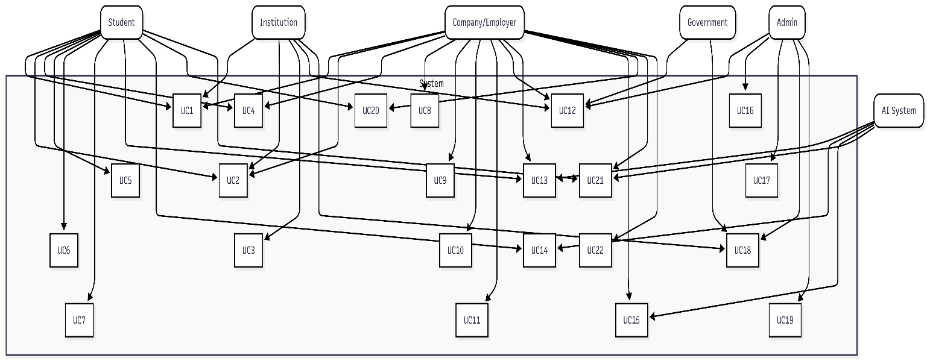
Diagram Explanation:
This Use Case Diagram provides a comprehensive overview of all system functionalities and their relationships with six actor categories: Students, Companies/Employers, Institutions, Administrators, Government users, and the AI System. Students can register, manage profiles, search and apply for jobs, track applications, and communicate. Companies can post jobs, review candidates, schedule interviews, and access AI matching. Institutions focus on verification and reporting. Administrators handle user management and content moderation. Government users access analytics for policymaking. The AI System autonomously powers matching, assessment, and recommendations.

Diagram 2: Student Registration Sequence

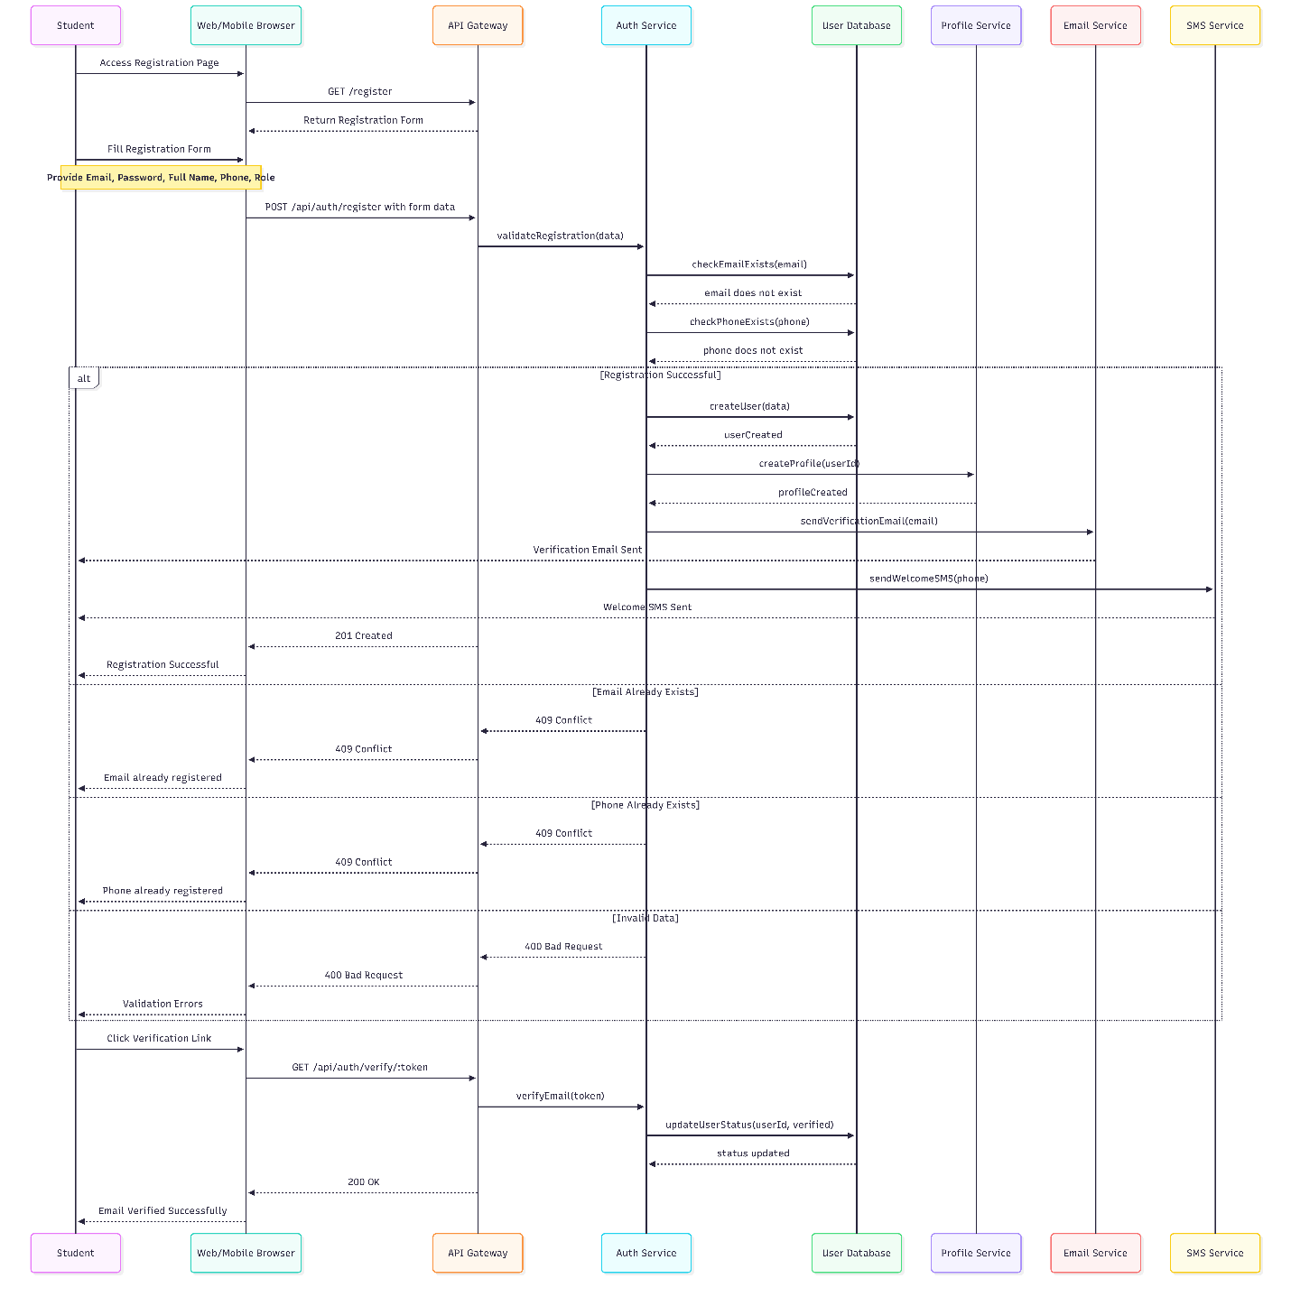
Diagram Explanation:
This sequence diagram illustrates the complete student registration flow. The student accesses the registration page and submits their details. The system validates email and phone uniqueness. Upon successful validation, a user record is created, profile is generated, verification email and welcome SMS are sent simultaneously. Success response returns 201 Created. For validation failures, appropriate 400 or 409 error codes return with user-friendly messages. The second part shows email verification where clicking the link updates user status to verified.

Diagram 3: Student Login Sequence
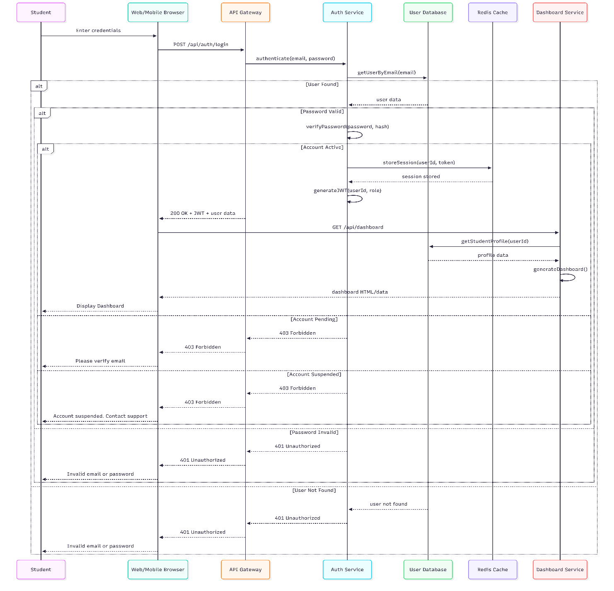
Diagram Explanation:
This sequence diagram shows the student login flow. The system first checks if the user exists, then verifies password validity. For active accounts, a session is stored in Redis, JWT token is generated, and dashboard data is fetched and displayed. Different error paths handle pending verification, suspended accounts, invalid passwords, and non-existent users - all returning appropriate HTTP status codes and user-friendly messages.

Diagram 4: Job Search and Filter Sequence
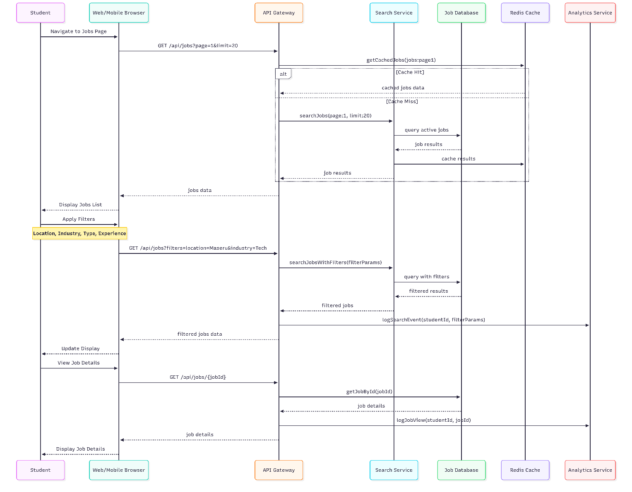
Diagram Explanation:
This sequence diagram details job search functionality. Initial job listing uses Redis caching for performance. When cache miss occurs, the search service queries the database and caches results. Filters trigger dynamic database queries with search events logged for analytics. Viewing job details retrieves specific job information and logs the view for recommendation algorithms.

Diagram 5: Job Application Sequence

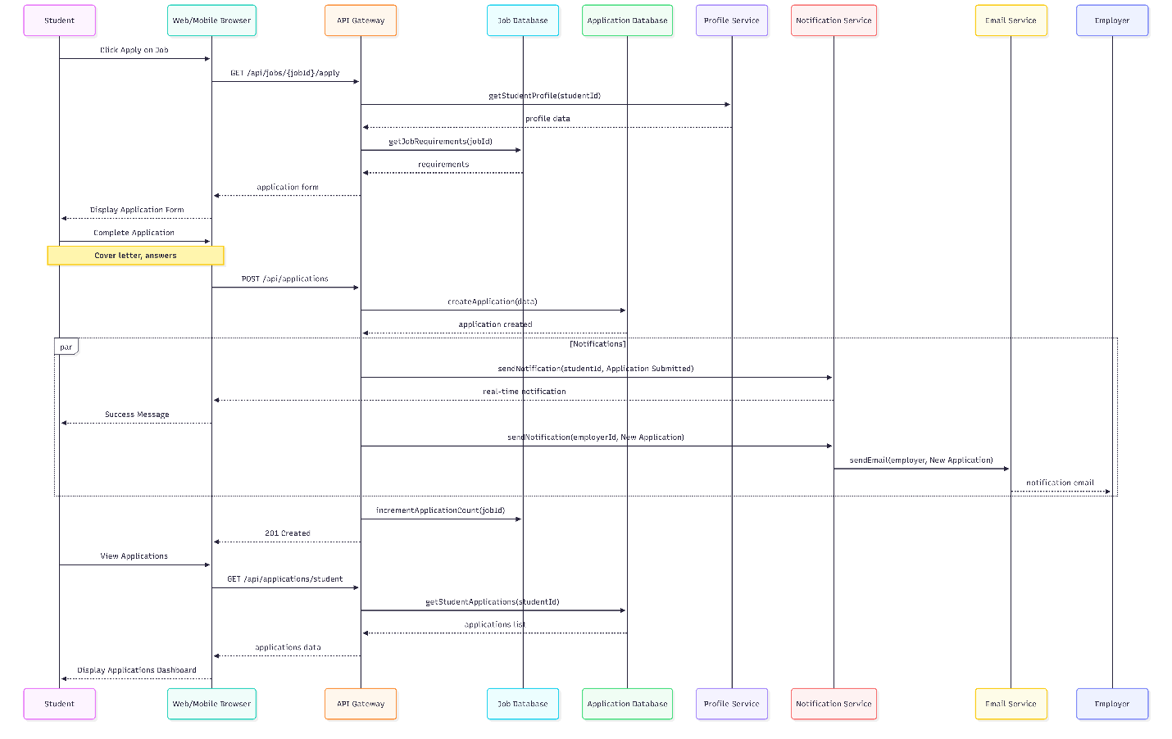
Diagram Explanation:
This sequence diagram shows the job application process. Student requests application form, which pre-fills with profile data. Upon submission, application is created in database. Parallel notifications are sent to both student (confirmation) and employer (new application alert) via real-time notifications and email. Application count for the job is incremented. Student can later view all applications in their dashboard.

Diagram 6: Employer Job Posting Sequence
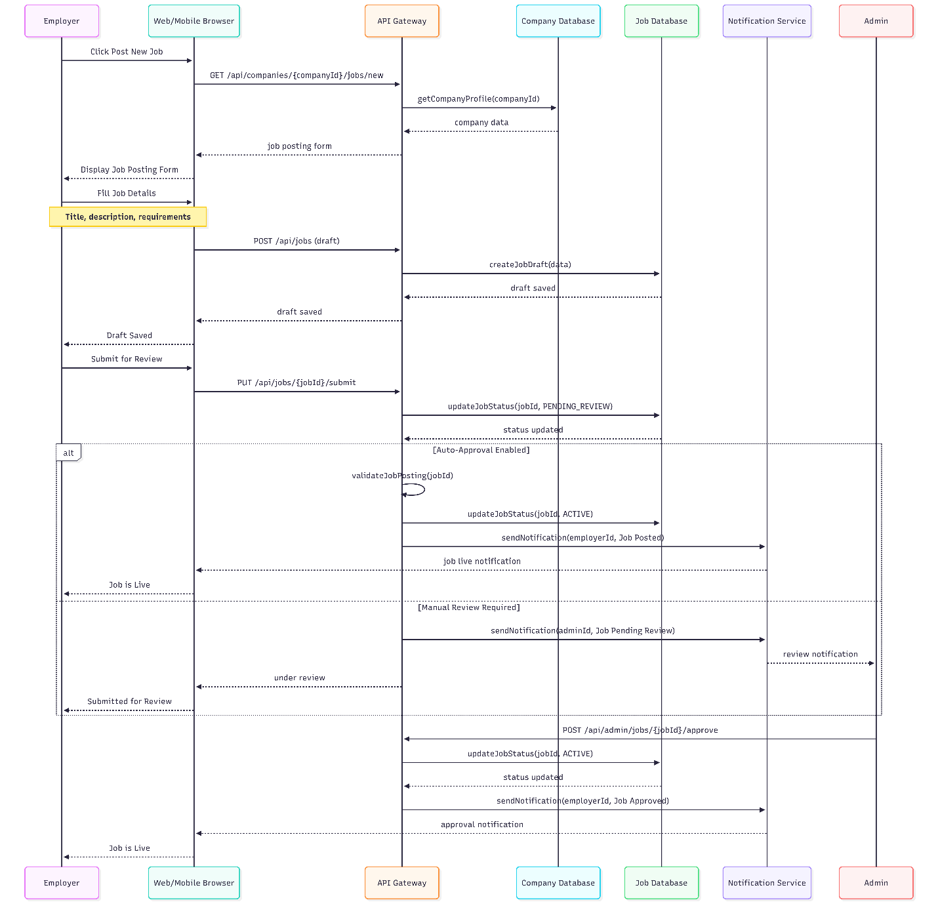
Diagram Explanation:
This sequence diagram illustrates employer job posting workflow. Employer creates job draft first, then submits for review. The system branches based on auto-approval settings: auto-approved jobs go live immediately with notification to employer; jobs requiring review are flagged for admin approval. Admin receives notification, reviews, and upon approval, job goes live with employer notification.

Diagram 7: AI Matching Engine Sequence
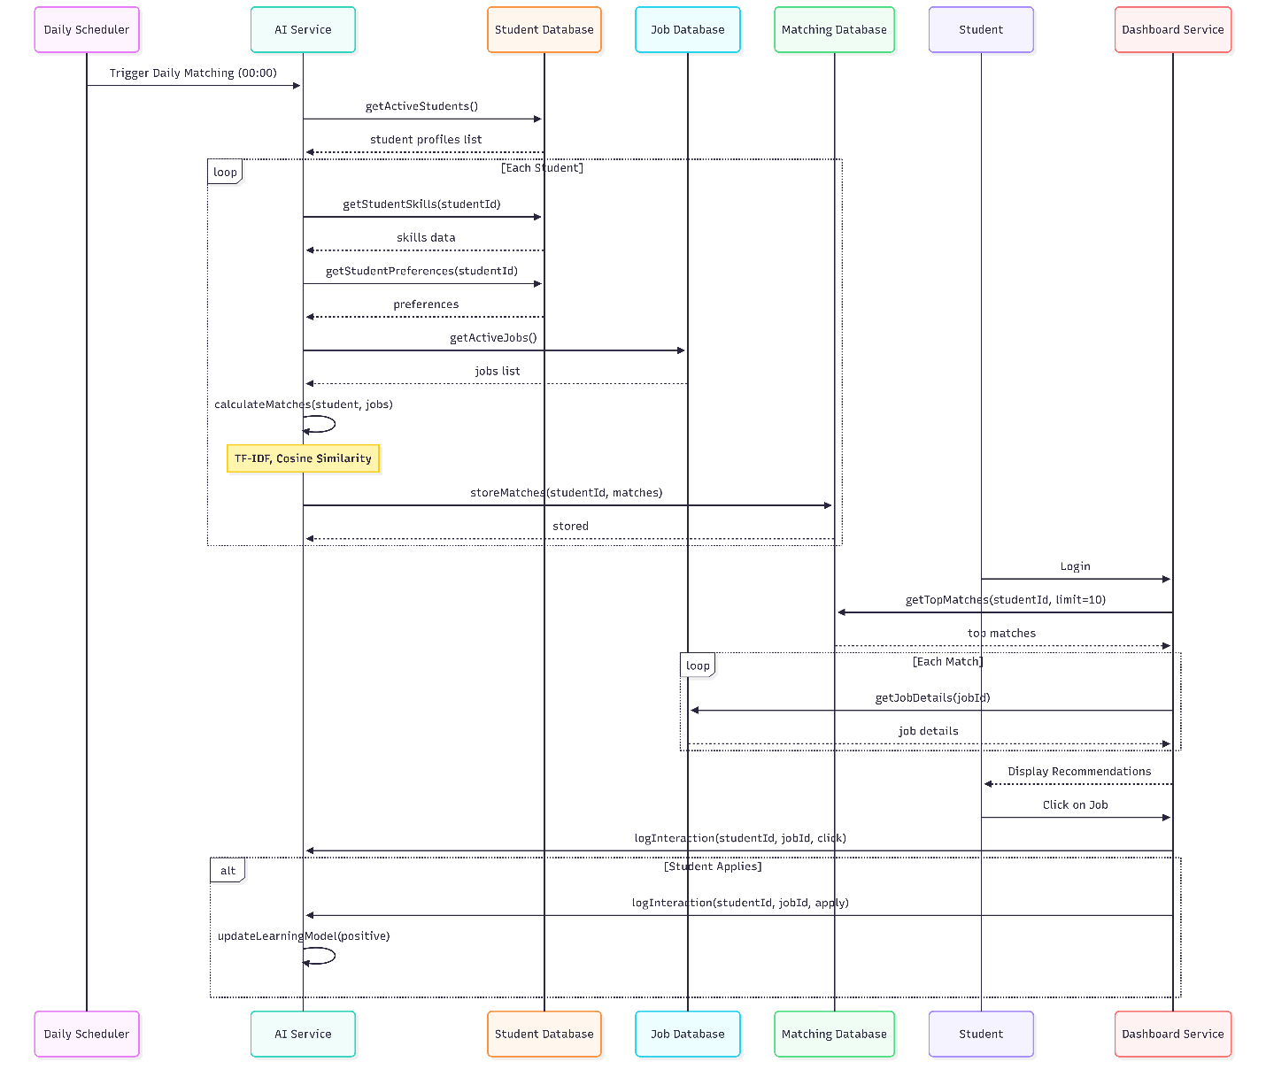
Diagram Explanation:
This sequence diagram shows the AI matching engine workflow. A daily scheduler triggers the matching process at midnight. For each active student, the AI service retrieves skills, preferences, and all active jobs, then calculates match scores using algorithms like TF-IDF and cosine similarity. Results are stored in the matching database. When student logs in, dashboard retrieves top matches with job details. Student interactions (clicks, applies) are logged to improve future recommendations through continuous learning.
Diagram 8: Messaging System Sequence
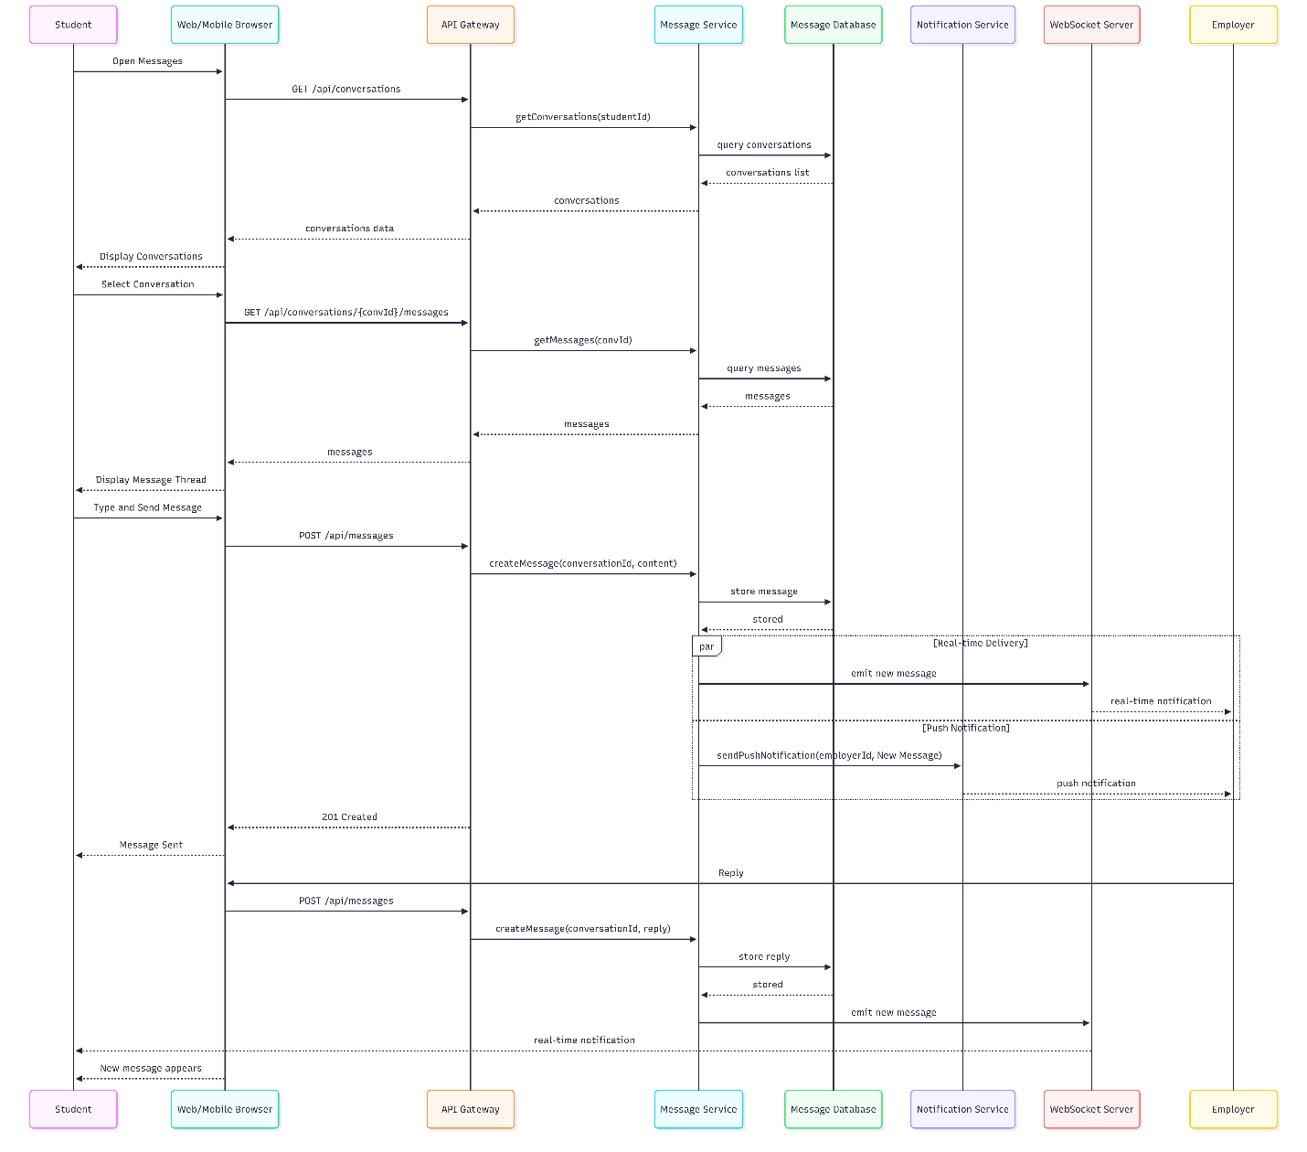
Diagram Explanation:
This sequence diagram illustrates the real-time messaging system. Student retrieves conversation list, then views specific conversation history. When sending a message, it's stored in database and simultaneously delivered via WebSocket for real-time experience and push notification for offline delivery. The employer receives and replies, with the reply delivered back to student through the same real-time channel. This ensures seamless communication experience.
Diagram 9: Interview Scheduling Sequence
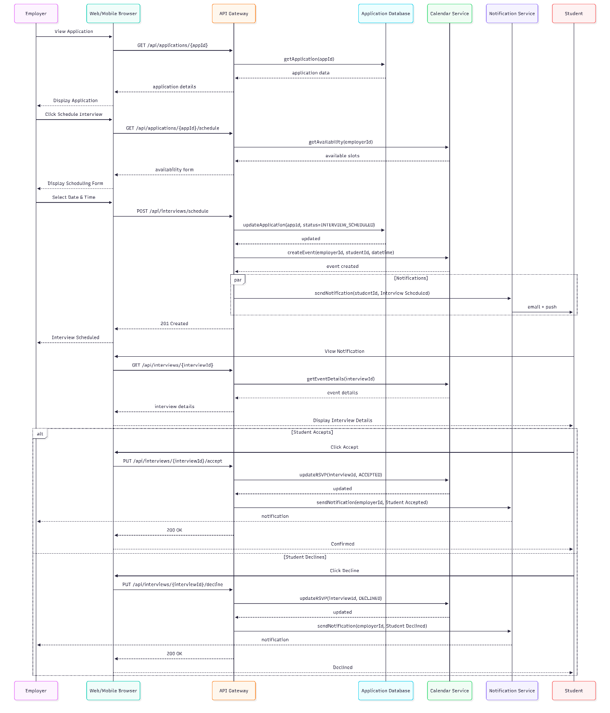
Diagram Explanation:
This sequence diagram shows interview scheduling workflow. Employer views application and initiates scheduling, selecting from available time slots. System updates application status, creates calendar event, and notifies student. Student receives notification, views details, and can accept or decline. Both actions update calendar RSVP and notify employer of student's decision.
Diagram 10: Admin User Management Sequence
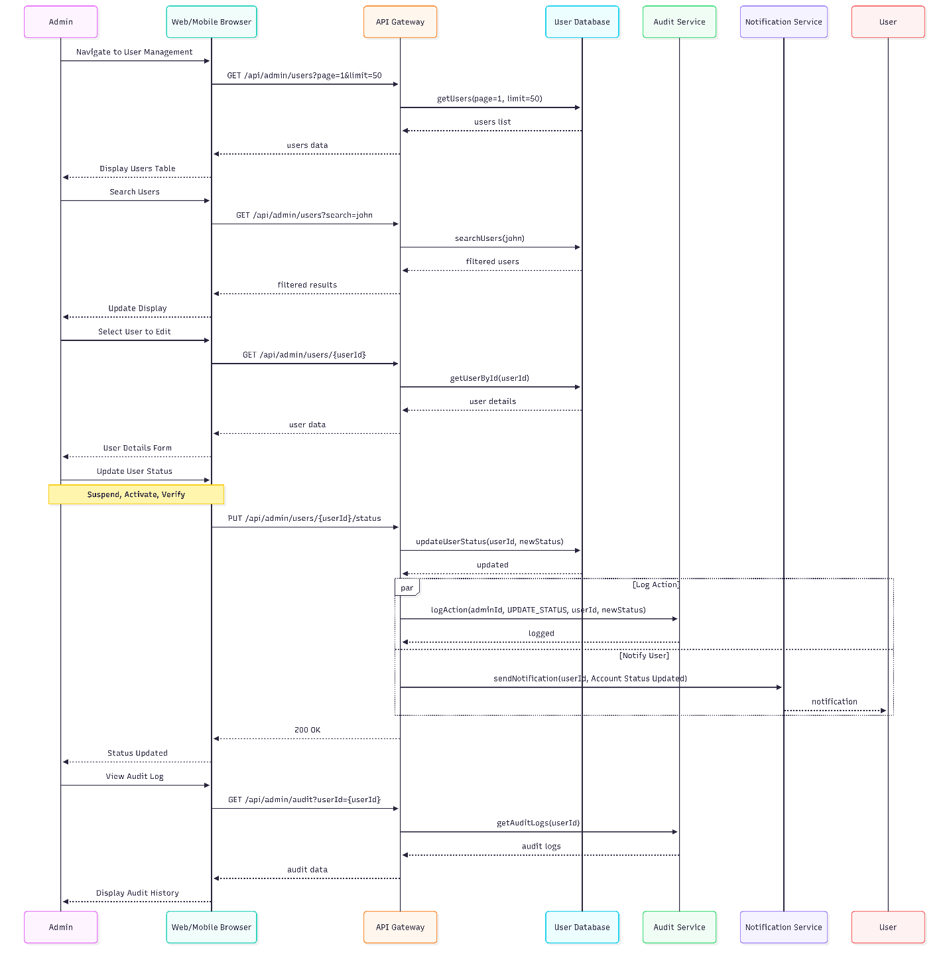
Diagram Explanation:
This sequence diagram shows admin user management capabilities. Admin can view paginated user lists, search for specific users, and access detailed user information. When updating user status (suspend, activate, verify), the system updates the database, logs the action for audit trail, and notifies the affected user. Admin can also view complete audit history for any user, ensuring transparency and accountability.
Diagram 11: Report Generation Sequence
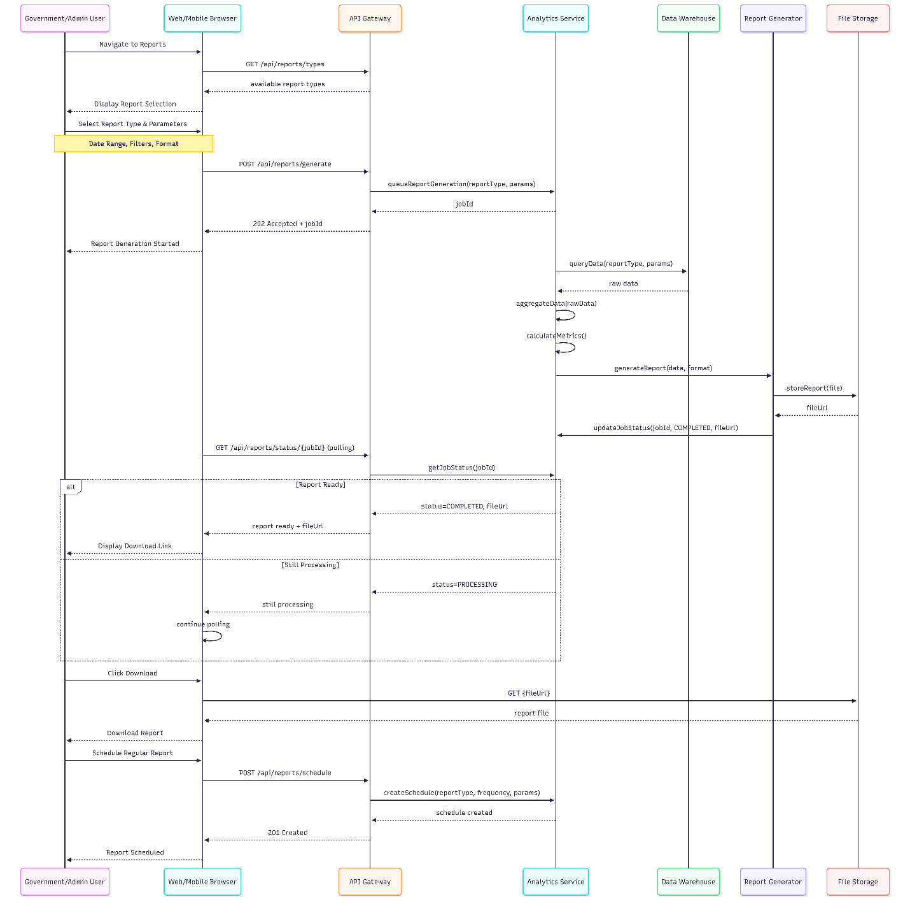
Diagram Explanation:
This sequence diagram illustrates report generation for government and admin users. User selects report type and parameters, triggering asynchronous report generation with job ID returned immediately. The system queries the data warehouse, aggregates data, calculates metrics, and generates formatted report (PDF/Excel/CSV). Client polls for status, then downloads when ready. Users can also schedule recurring reports with specified frequency.
Diagram 12: Skills Assessment Sequence
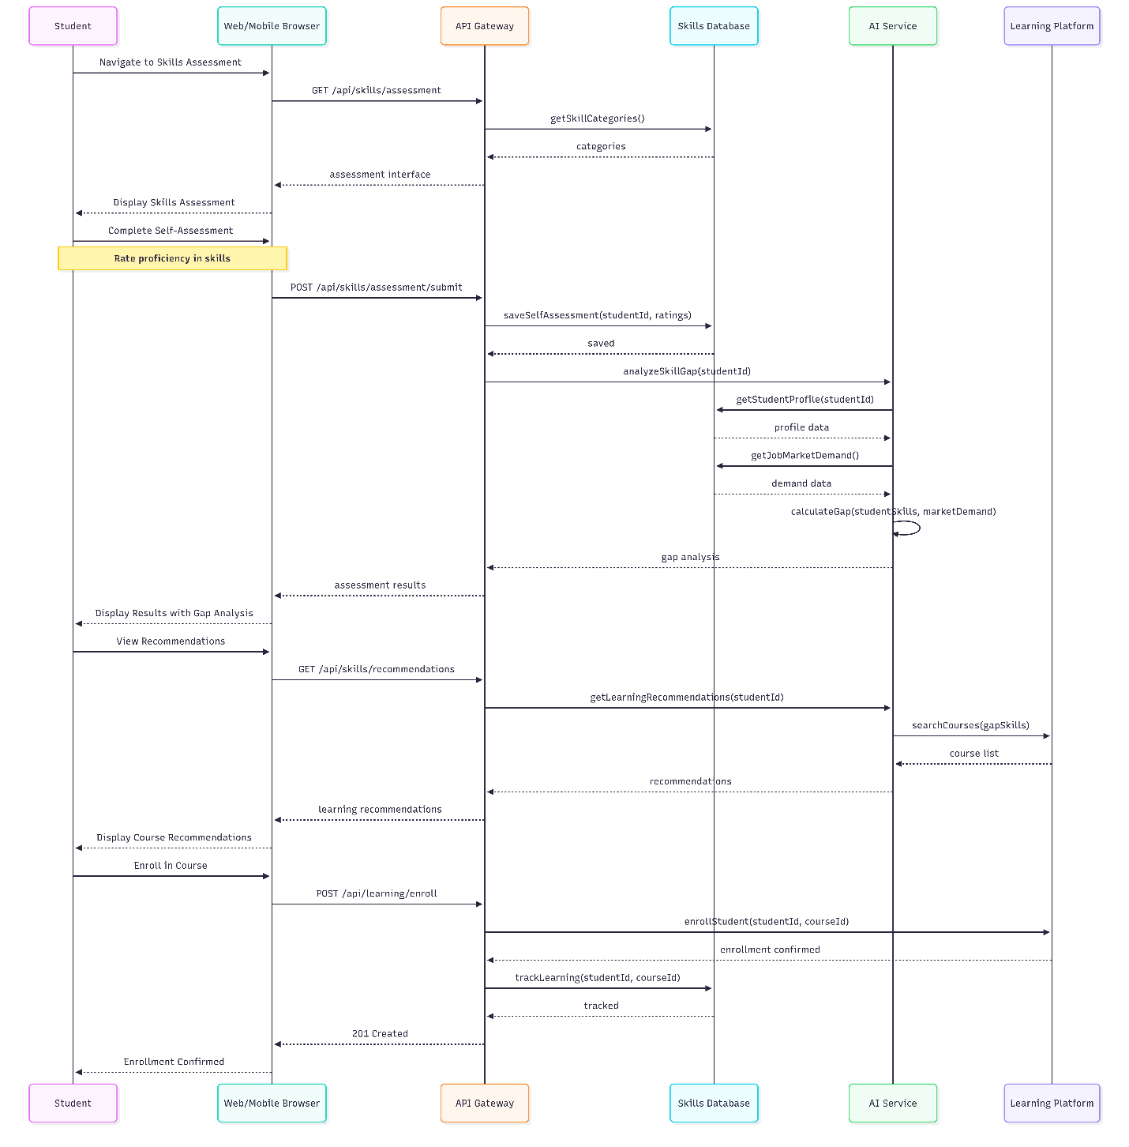
Diagram Explanation:
This sequence diagram shows skills assessment workflow. Student completes self-assessment of skill proficiencies. The AI service analyzes gaps between current skills and market demand, generating personalized gap analysis. Based on identified gaps, AI recommends relevant courses from learning platforms. Student can enroll directly, with enrollment tracked for progress monitoring and future recommendations.

Diagram 13: Activity Diagram - Complete Job Search Journey
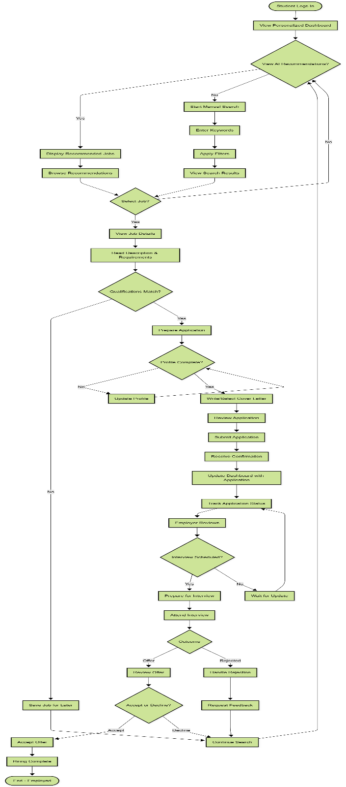
Diagram Explanation:
This comprehensive activity diagram maps the complete student job search journey from login to employment. It shows parallel paths of AI recommendations versus manual search, decision points for job selection based on qualifications, application preparation workflow with profile completeness checks, and post-submission tracking. The diagram also covers interview process, offer acceptance/rejection, and handling rejection with feedback requests. This holistic view ensures all user journey paths are accounted for.
Diagram 14: Component Diagram - System Architecture
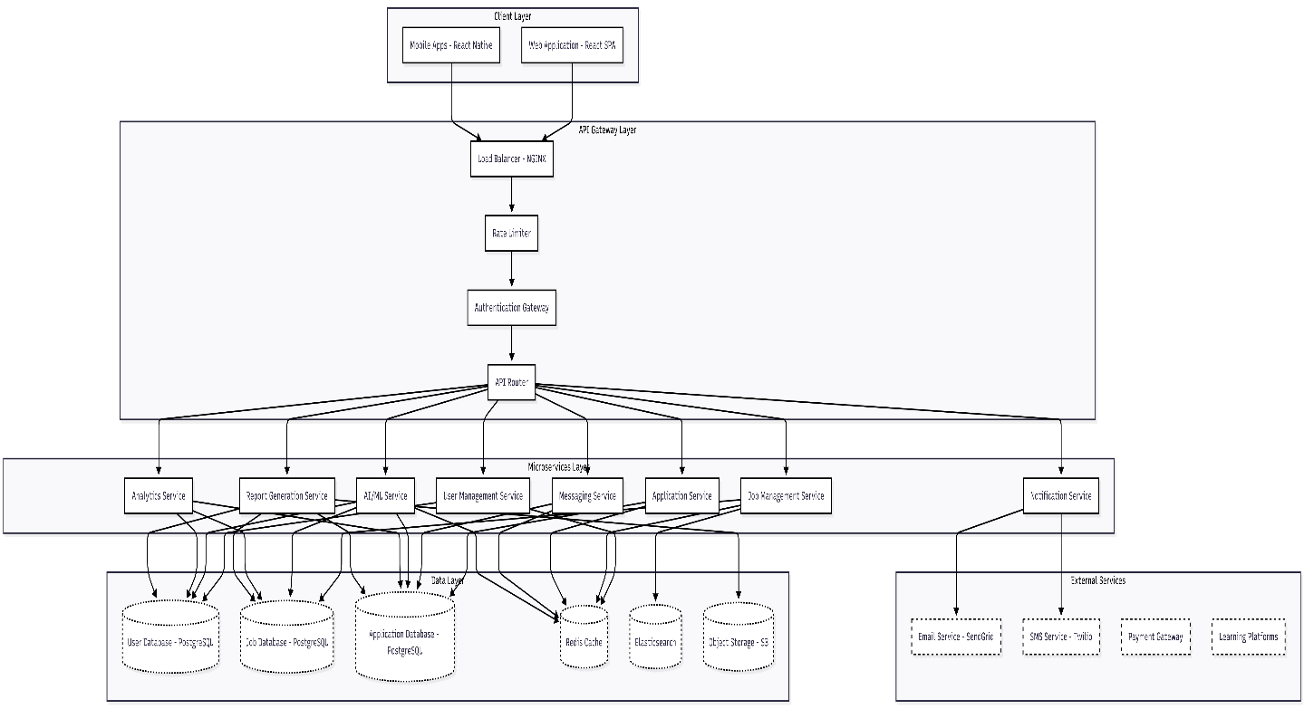
Diagram Explanation:
This component diagram shows the complete system architecture across four layers. Client Layer contains web and mobile applications. API Gateway Layer handles load balancing, rate limiting, authentication, and routing. Microservices Layer contains seven specialized services for different business functions. Data Layer includes multiple databases for different data types with appropriate technologies (PostgreSQL for relational data, Redis for caching, Elasticsearch for search). External Services integrate with third-party providers for email, SMS, payments, and learning content.

Diagram 15: Deployment Diagram - Infrastructure
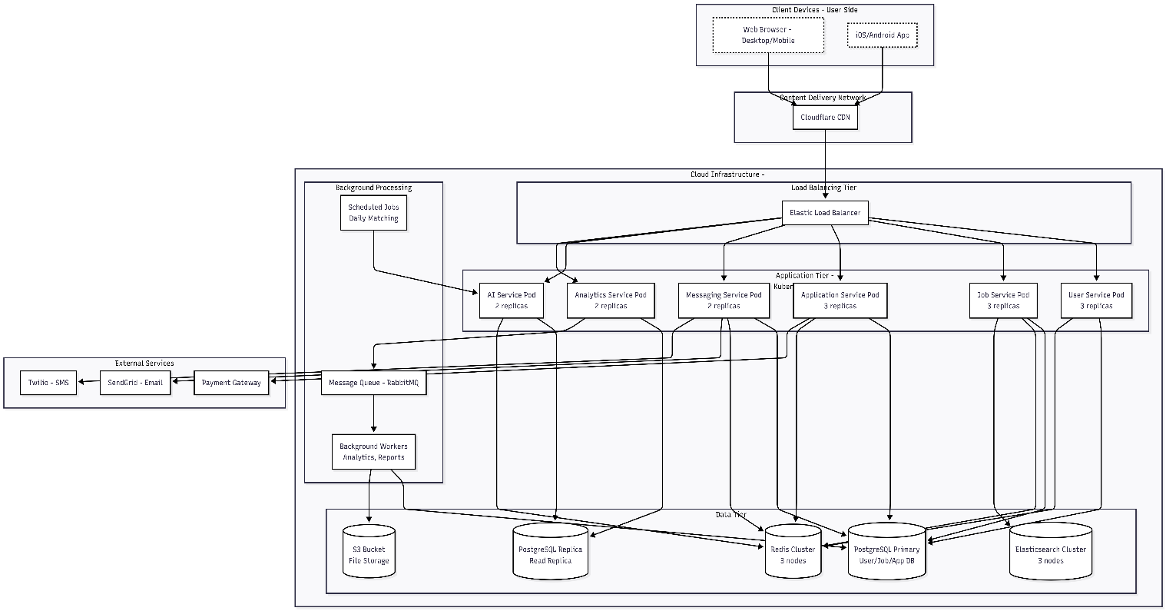
Diagram Explanation:
This deployment diagram illustrates the production infrastructure on cloud platforms like AWS/Azure. Client requests route through CDN for performance. Load balancer distributes traffic across Kubernetes pods with multiple replicas for high availability. Data tier includes primary database, read replicas for AI/analytics workloads, Redis cluster for caching, Elasticsearch for search, and S3 for file storage. Background processing uses message queues and workers for asynchronous tasks. External services handle email, SMS, and payments. This architecture ensures scalability, reliability, and performance.

Diagram 16: State Diagram - Application Lifecycle
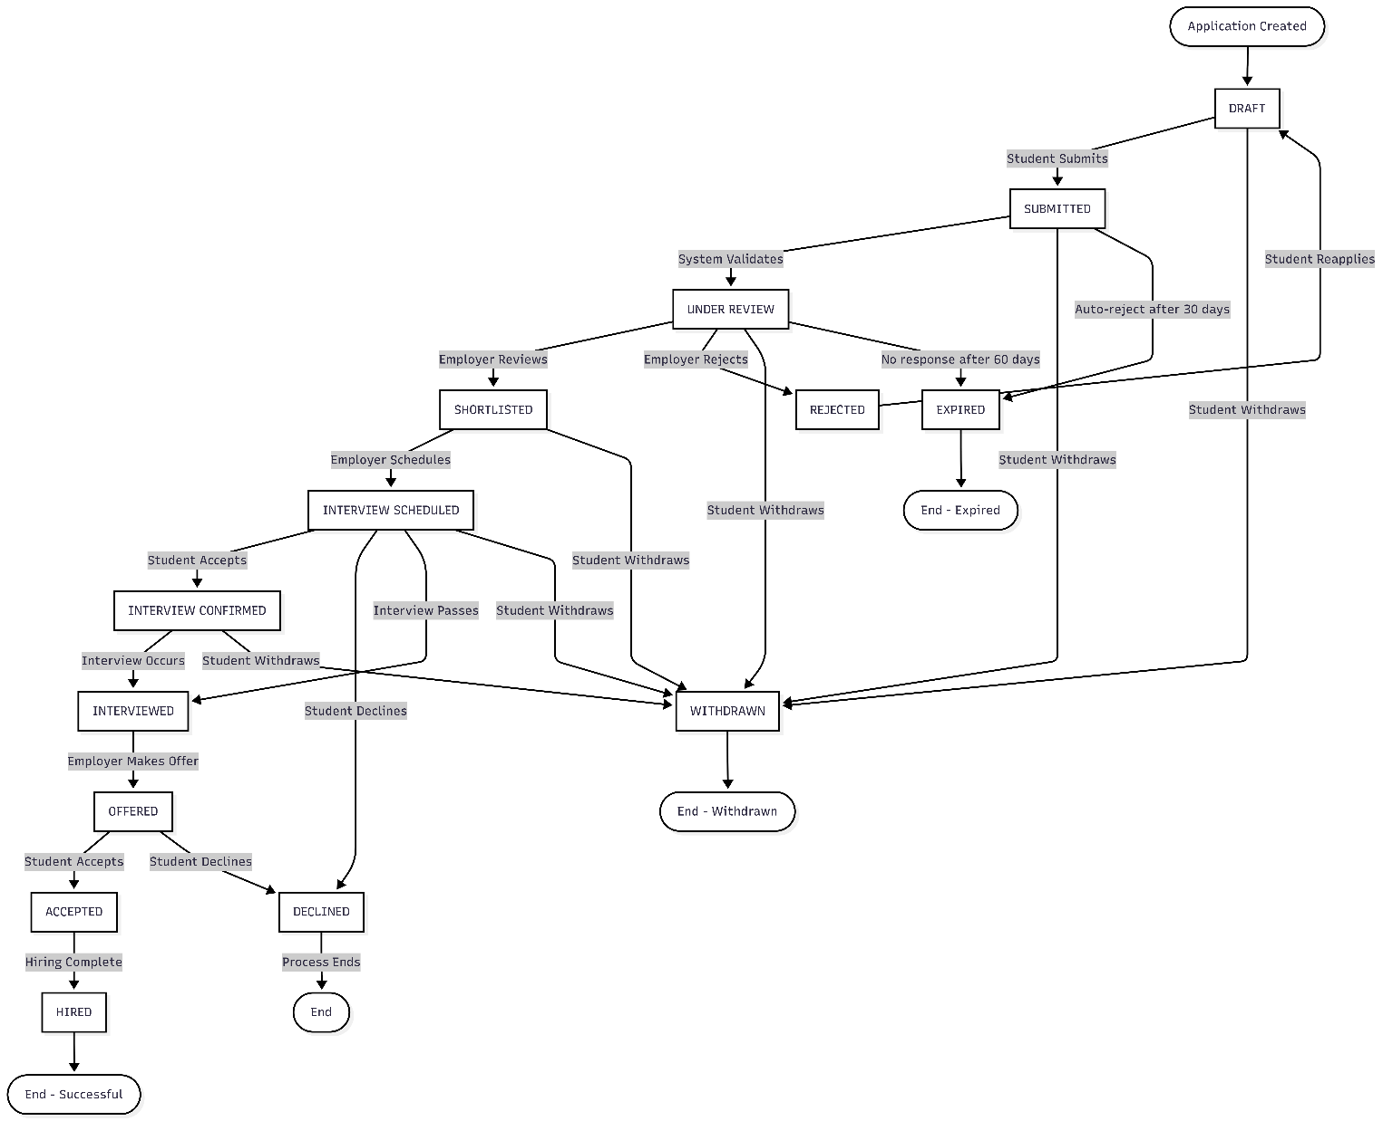
Diagram Explanation:
This state diagram tracks an application's complete lifecycle from creation through hiring. States include Draft, Submitted, Under Review, Shortlisted, Interview Scheduled, Interview Confirmed, Interviewed, Offered, Accepted, Hired, Rejected, Declined, Withdrawn, and Expired. Transitions show all possible paths including successful hiring, rejection at various stages, withdrawal by student, and automatic expiration after timeout periods. This comprehensive state model ensures all application statuses are properly tracked.

Diagram 17: Package Diagram - System Organization
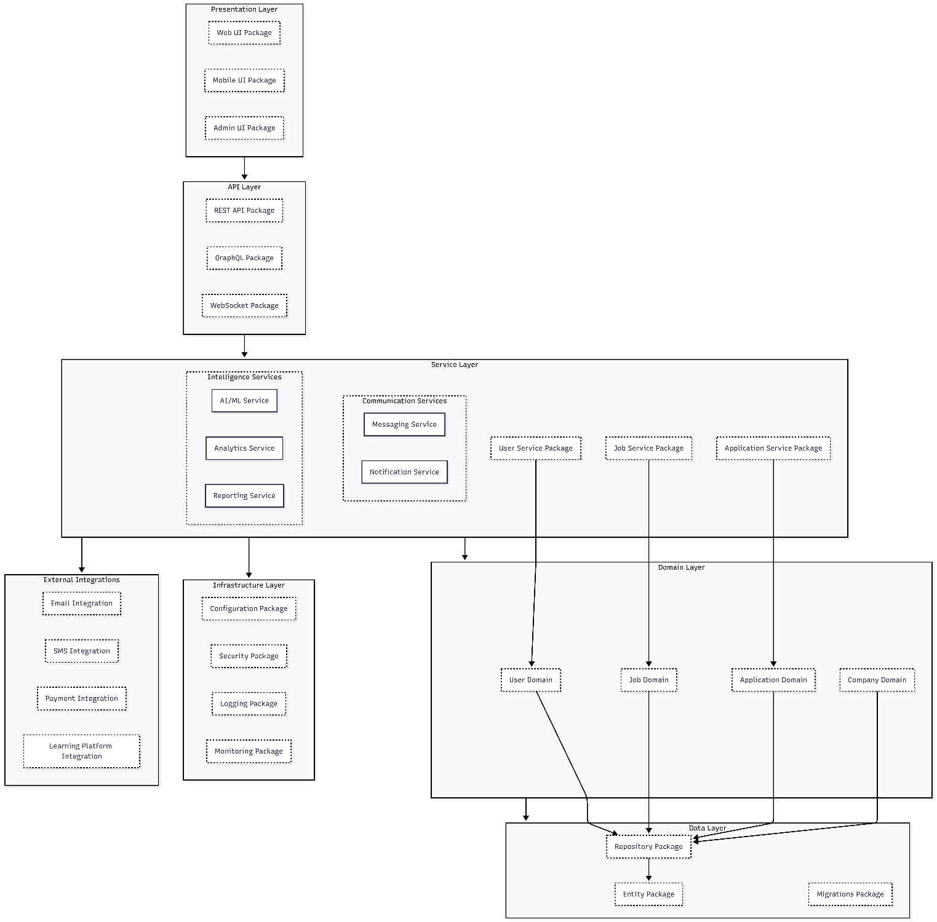
Diagram Explanation:
This package diagram shows the logical organization of system code across layers. Presentation Layer contains UI packages for different user types. API Layer exposes REST, GraphQL, and WebSocket interfaces. Service Layer organizes business logic into specialized service packages. Domain Layer contains core business entities and rules. Data Layer handles persistence with repositories and entities. Infrastructure Layer provides cross-cutting concerns like security and logging. External Integrations package manages connections to third-party services. Dependencies flow inward following clean architecture principles.
Diagram 18: Timing Diagram - Notification Delivery
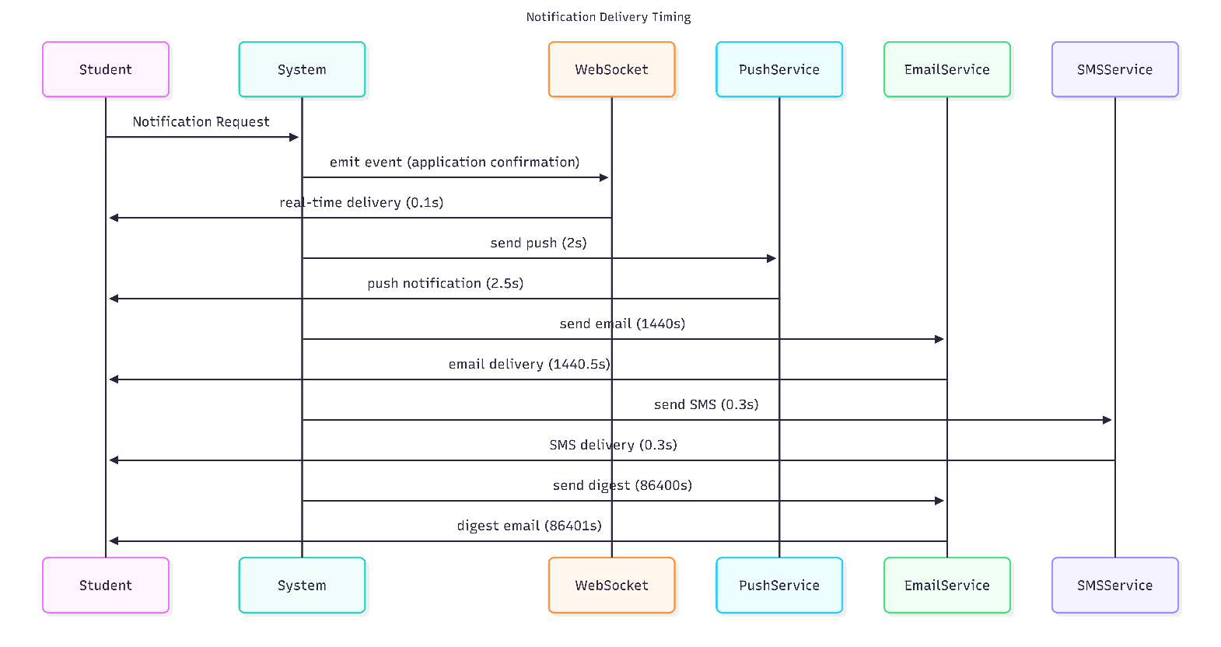
Diagram Explanation:
This timing diagram illustrates notification delivery timing across different channels. Real-time WebSocket notifications deliver within 100ms for immediate updates like application confirmation. Push notifications arrive within 1 second for recommendations. SMS delivers within 1 second for urgent messages. Email notifications may take up to 5 minutes for non-urgent communications like daily digests. The system chooses appropriate channels based on urgency and content type.

Diagram 19: Interaction Overview Diagram - Comple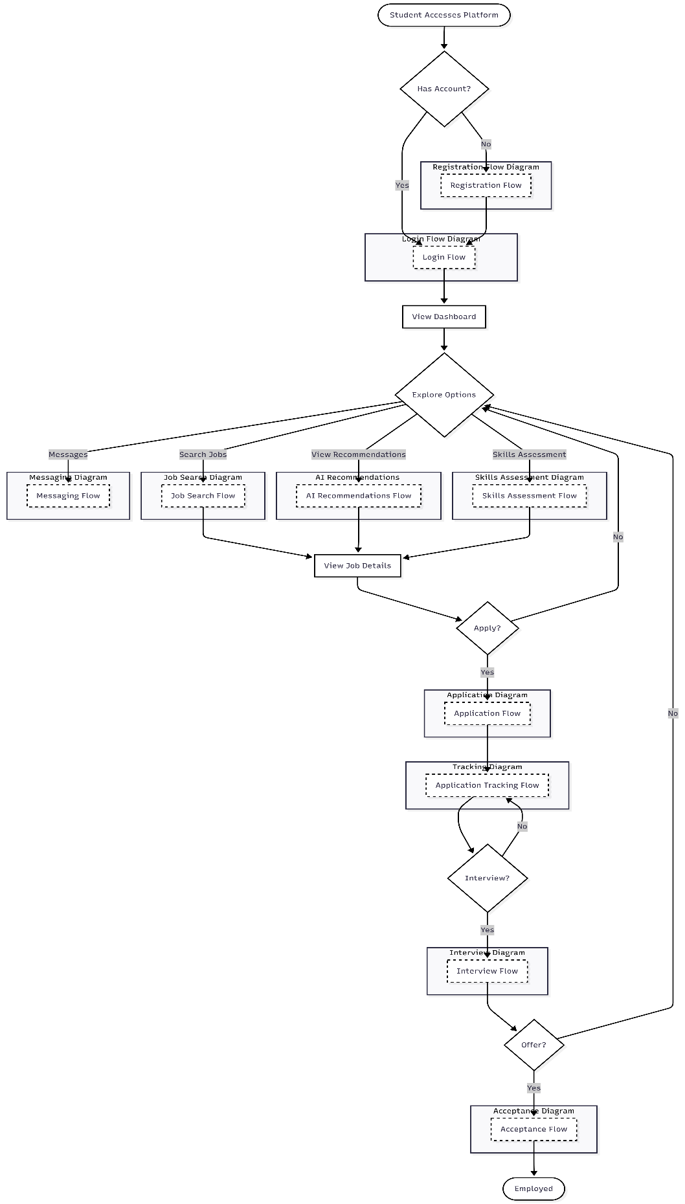
Diagram Explanation:
This interaction overview diagram provides a high-level view of the complete student user journey. It shows how individual sequence diagrams (registration, login, search, recommendations, assessment, messaging, application, tracking, interview, acceptance) interconnect to form the complete user experience. Each reference frame points to a detailed sequence diagram, showing how users navigate between different flows. This provides a roadmap for understanding the entire system from the user's perspective.

Diagram 20: Communication Diagram - Application Submission
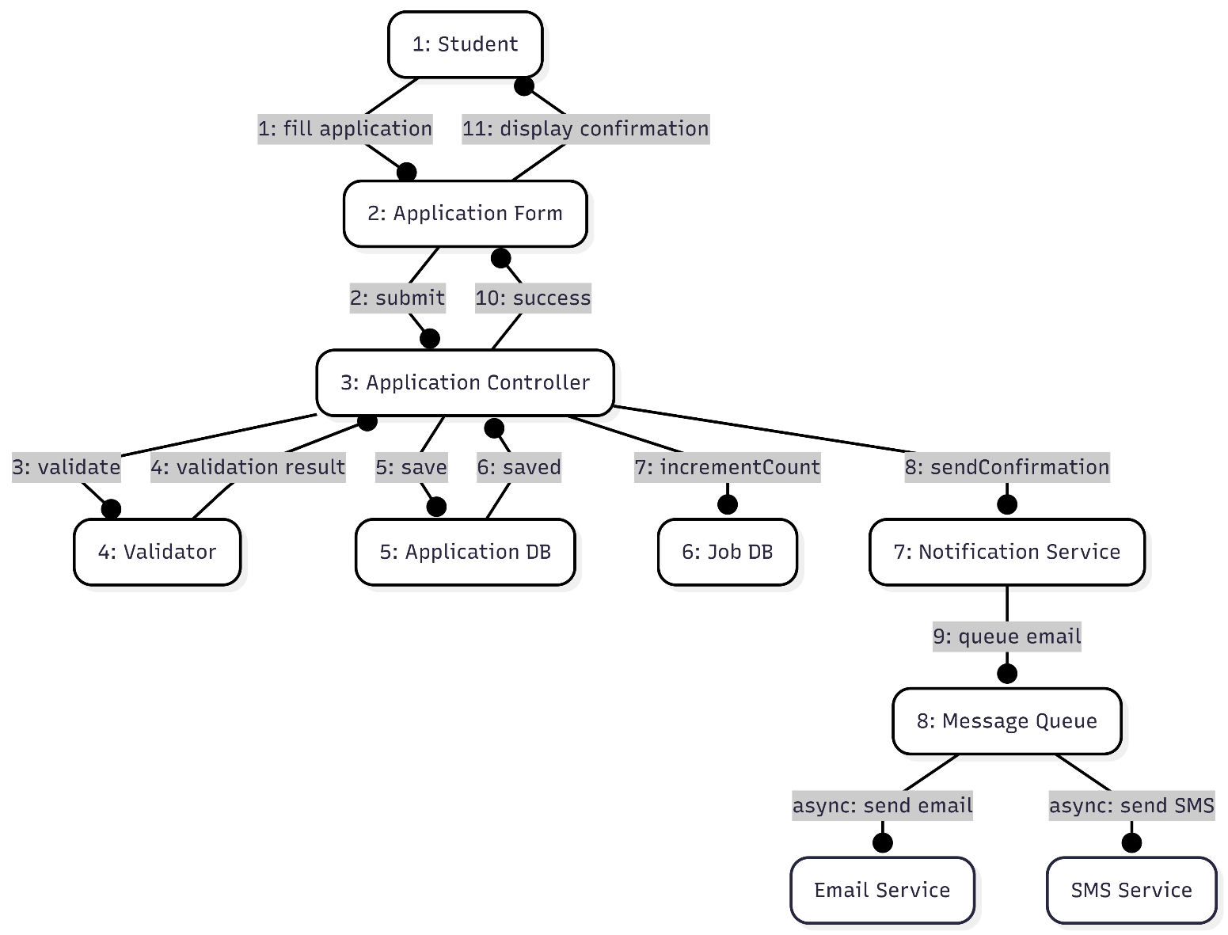
Diagram Explanation:
This communication diagram shows the object interactions during application submission, emphasizing the sequence of messages between objects. Student interacts with the form, which submits to controller. Controller coordinates validation, database persistence, job count increment, and notification triggering. Notifications are queued for asynchronous processing to maintain response time. Numbers show the sequence of messages, providing a clear view of the collaboration between objects.

Diagram 21: Entity Relationship Diagram (ERD) - Core Schema

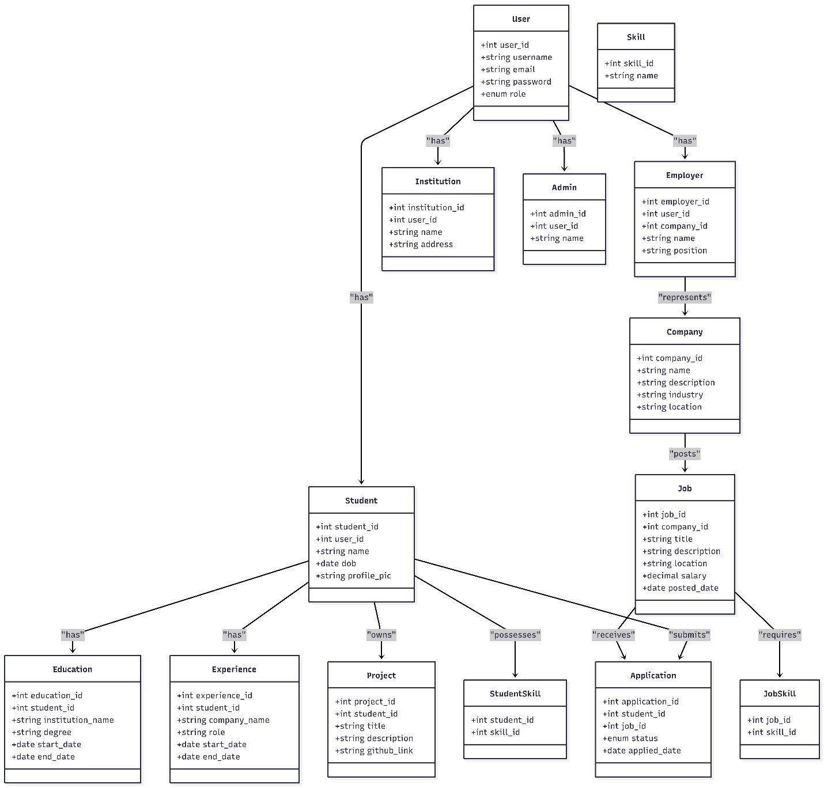
Diagram Explanation:
This Entity Relationship Diagram shows the core data model for Career Connect Lesotho. The central entity is User, which specializes into four actor types: Student, Employer, Institution, and Admin. Students have education history, work experience, projects, and can submit applications and save items. Companies post jobs and internships, receive reviews, and publish news. The diagram illustrates all key relationships including one-to-many relationships between parents and children, and many-to-many relationships resolved through junction tables.

Identifying Classes/Objects
1️⃣ User & Derived Classes

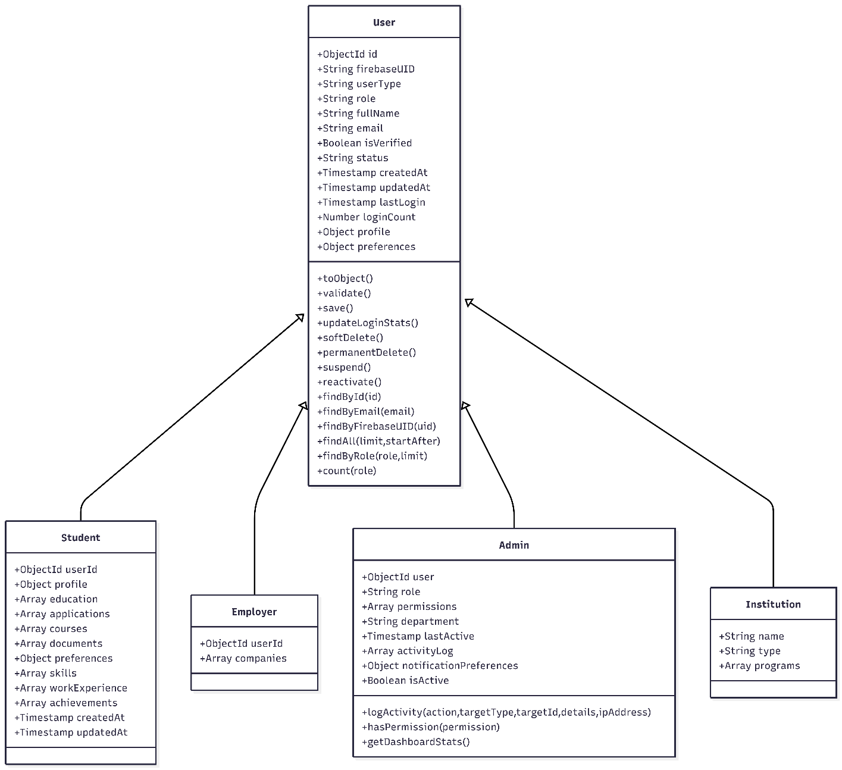

2️⃣ Company & Job Module
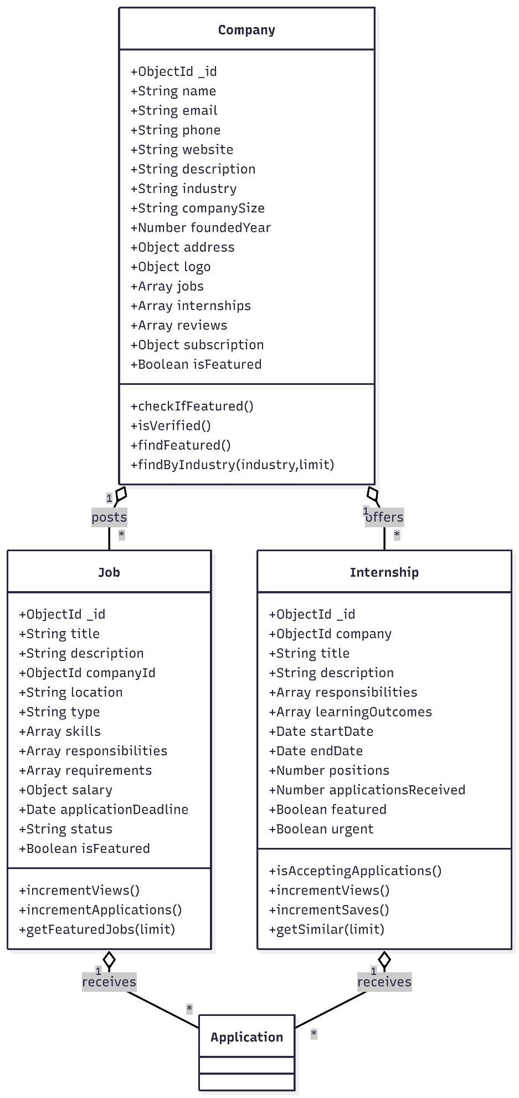
3️⃣ Application, Message & Notification Module
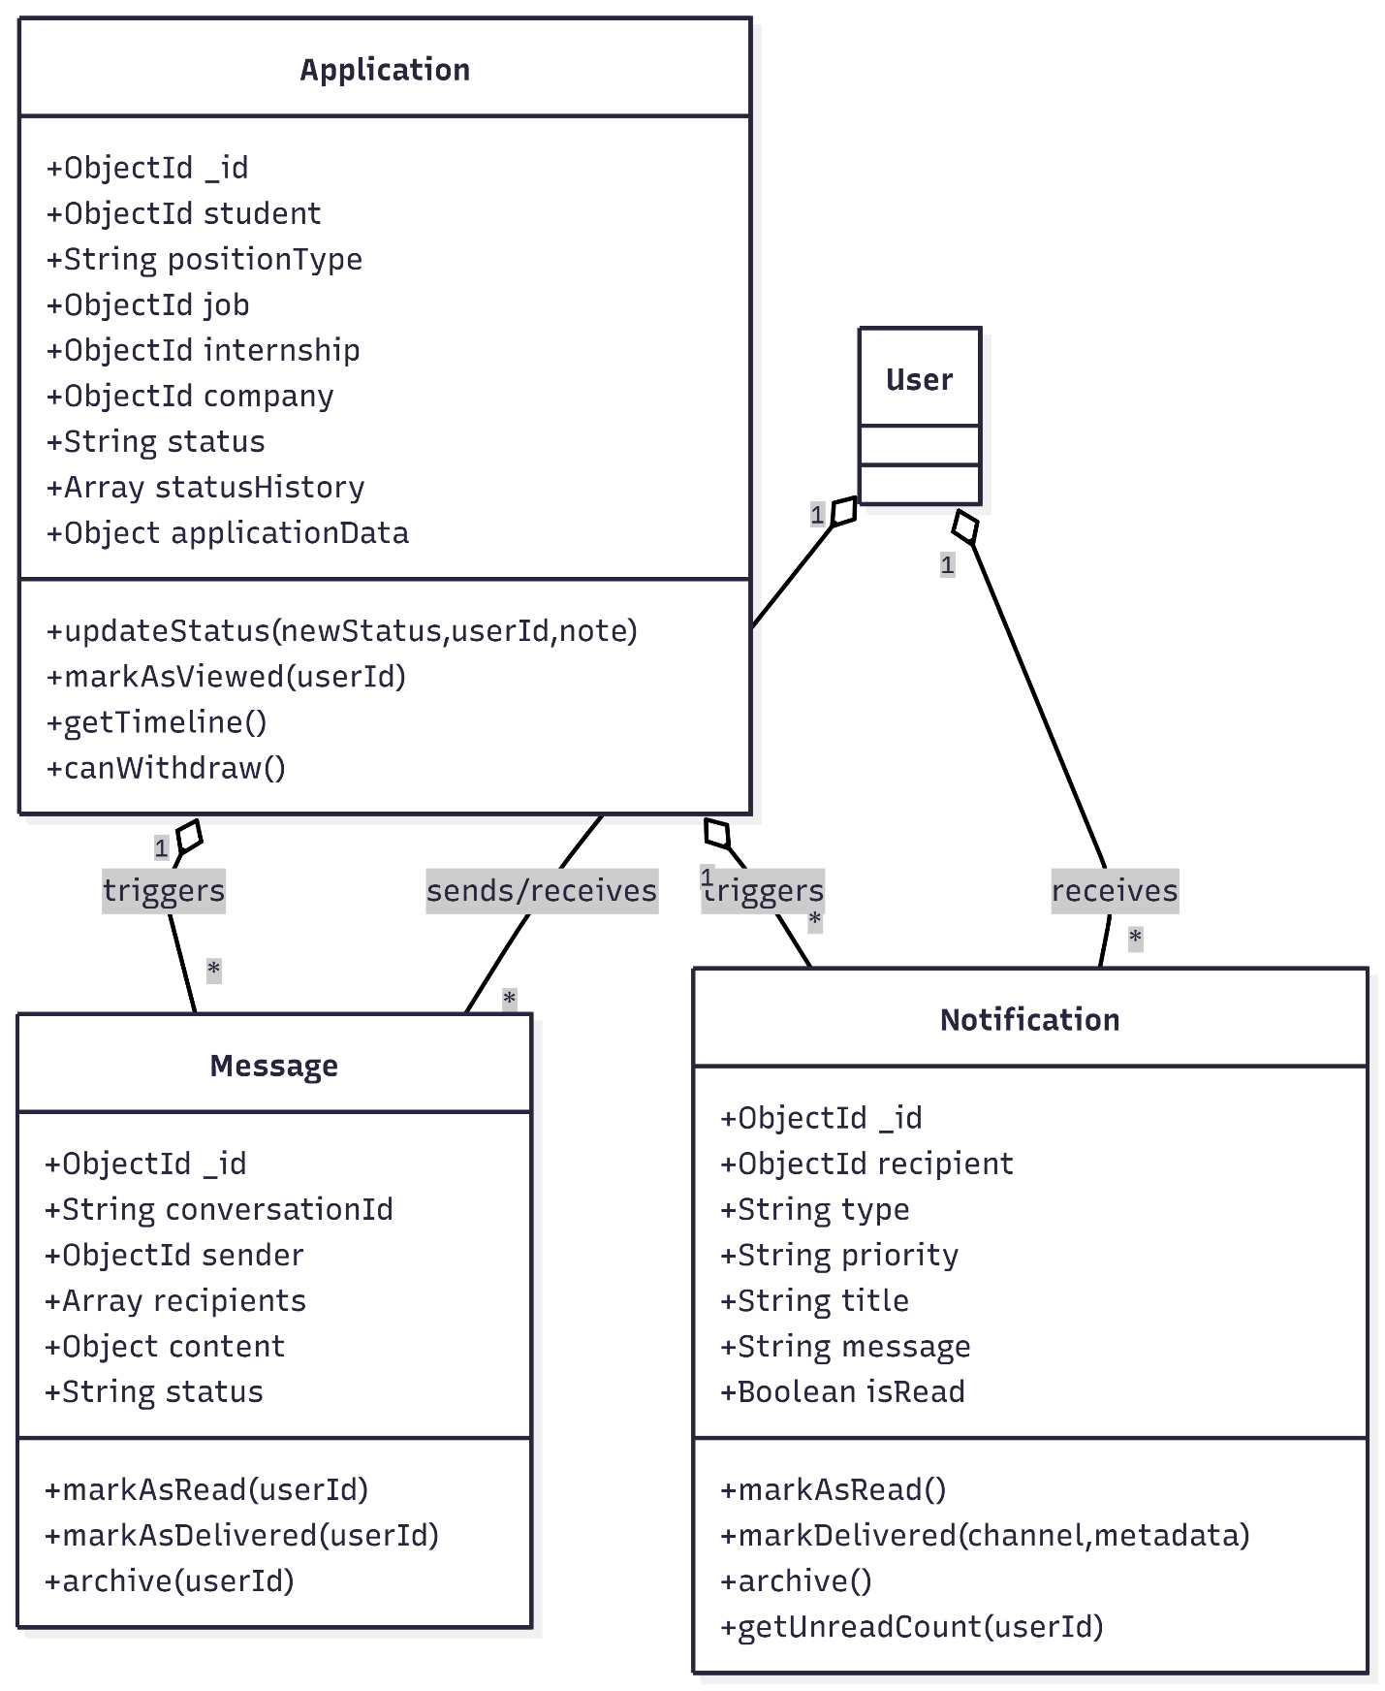

4️⃣ AI/ML Predictor Classes Overview
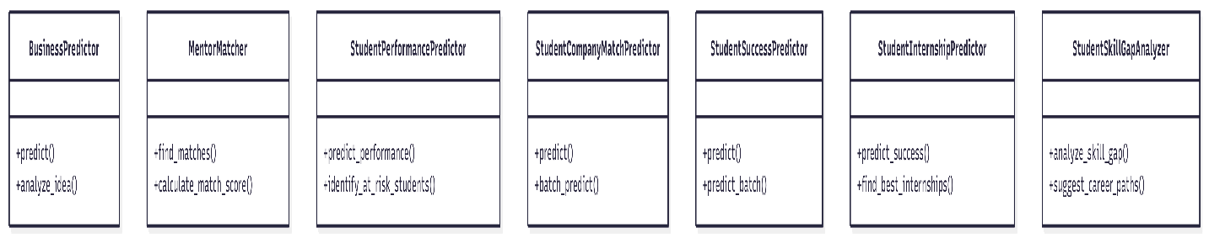

14.6 Software development life cycle process adopted
The software development life cycle (SDLC) is a systematic process for designing, developing, and testing software. It consists of a series of phases that guide the project from start to finish (Gunnell, 2024). There are six primary phases of the SDLC:
Planning: The planning phase involves identifying the scope of the software project, defining objectives, and determining the project’s feasibility. It also includes creating a project plan, defining project requirements, and establishing the project team’s roles and responsibilities.
Requirements gathering: In this phase, the software development team works with stakeholders to define the software’s requirements, such as functionality, performance, and usability. The team documents these requirements and uses them to develop the software design.
Design: The design phase involves creating a detailed design plan that outlines the software’s architecture, components, and interface. The team also creates test plans, which will be used to test the software’s functionality and performance.
Development: In this phase, the team begins to develop the software according to the design and requirements gathered earlier. This involves writing code, integrating components, and testing the software’s functionality.
Testing: The testing phase involves testing the software’s functionality, performance, and usability. The team uses the test plans created during the design phase to conduct various tests, including unit tests, integration tests, and system tests. Any defects found during testing are logged and fixed before moving on to the next phase.
Deployment: The deployment phase involves releasing the software to the production environment, where it can be used by end-users. This phase includes tasks such as training end-users, configuring the software, and installing it on end-users’ devices (Nadene, 2023).

For the smart water metering system, we adopted the Agile SDLC methodology, which emphasizes iterative development, collaboration, and flexibility to adapt to changing requirements. The key phases of the Agile SDLC process as applied to our project.

1. Planning
In the planning phase, we defined the project scope, objectives, and deliverables. Key activities included:
- Stakeholder Identification: Engaging with stakeholders being users, utility managers, technical experts to gather initial requirements and expectations.
- Feasibility Study: Assessing technical, operational, and economic feasibility to determine the viability of the project.
- Project Roadmap: Developing a roadmap that outlines the phases of development, key milestones, and timelines.
2. Requirements Gathering and Analysis
This phase involved collecting detailed functional and non-functional requirements through various methods:
- Surveys: Conducted online surveys to gather quantitative data from a broad audience.
- Interviews: Held in-depth interviews with key stakeholders to gain qualitative insights.
- Focus Groups: Facilitated discussions with potential users to explore their needs and preferences in a collaborative setting.
- Requirements Documentation: Compiled and prioritized the gathered requirements to create a comprehensive requirements specification document.
3. Design
The design phase transformed requirements into a structured framework that guides development. Key activities included:
- System Architecture Design: Defining the overall architecture, including components, modules, and data flows.
- User Interface Design: Creating wireframes and prototypes for the mobile application to ensure an intuitive user experience.
- Database Design: Designing the database schema to support data storage and retrieval for the application.
4. Development
In the development phase, the actual coding and implementation of the system take place:
- Iterative Development: Utilizing Agile sprints to develop features incrementally, allowing for continuous feedback and adjustments.
- Version Control: Implementing version control systems to manage code changes and collaboration among developers.
- Unit Testing: Conducting unit tests during development to ensure individual components function correctly.
5. Testing
The testing phase will ensure that the system meet the specified requirements and is free of defects by involving:
- Integration Testing: Testing interactions between different components and systems to ensure seamless integration.
- User Acceptance Testing : Involving end-users to validate that the system meets their needs and expectations.
- Performance Testing: Assessing the system’s performance under various load conditions to ensure it meets non-functional requirements.
6. Deployment
Once testing is complete and the system is approved, the deployment phase will begin:
- Production Deployment: Launching the smart water metering system in a live environment.
- Training: Providing training sessions for users and administrators to familiarize them with the system’s functionalities.
- Documentation: Creating user manuals and technical documentation to support ongoing use and maintenance.
7. Maintenance and Support
The final phase involves ongoing maintenance and support to ensure the system remains functional and relevant:

14.7 System Behaviour
Illustrating system behaviour involves demonstrating how a system functions under different scenarios. This is commonly achieved using Unified Modelling Language (UML) diagrams, such as use case diagrams or sequence diagrams. These visual tools highlight how system components, users, and external entities interact to achieve desired outcomes, making system processes transparent and understandable (Booch, et al., 2020).
In our project, this will help us to define how each component interacts within the system. This includes how smart meters send usage data to the backend, how the data is processed, and how users (WASCO personnel and customers) interact with the system. Using diagrams like sequence and use case diagrams will visually represent the flow of data, such as how a customer checks their water usage or how WASCO monitors the system for irregularities. This approach helps ensure that all components work together efficiently.
A sequence diagram is a graphic depiction of the interactions between items in a system that shows the order in which messages are sent back and forth.
We have diagrams of sequence diagrams.
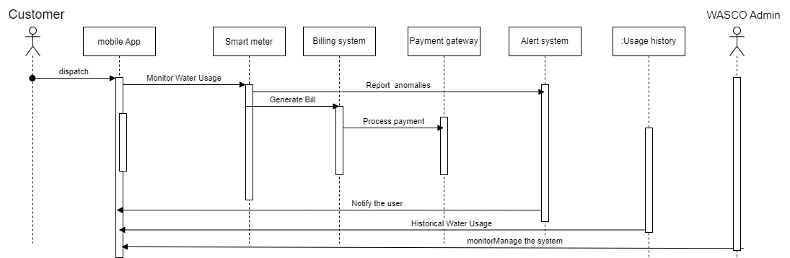
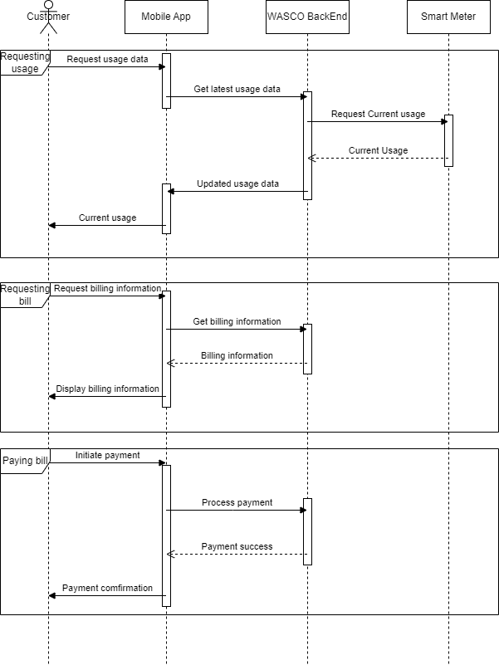

Activity diagram
An activity diagram is used to show the flow of control or actions in a process. It represents the sequence of tasks, decisions, and activities, often visualizing a workflow or the behaviour of a system. Each action or task is depicted as a rounded rectangle, and decision points are shown as diamonds, with arrows indicating the flow between them. The diagram can also represent parallel actions, where multiple tasks can happen simultaneously. It's helpful for illustrating how processes progress, where decisions are made, and how tasks depend on one another. Activity diagrams are commonly used to visualize business processes, software workflows, or any system with complex step-by-step actions. They make it easier to understand the process and spot inefficiencies or bottlenecks.
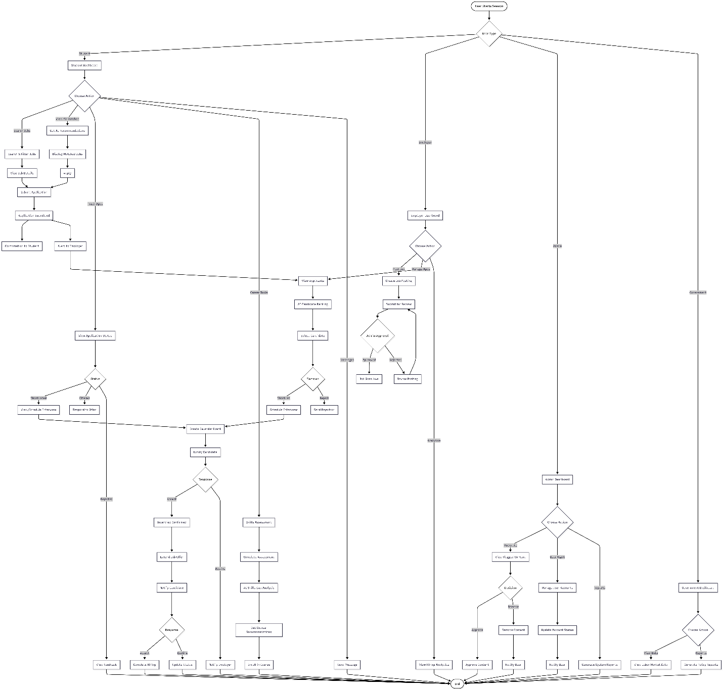

14.8 Systems Architecture
Systems architecture is a conceptual blueprint defining the structure, components, and relationships within a system. It guides the integration of software, hardware, and processes to achieve performance and scalability objectives.
System architecture explains how every piece of software and hardware works together to give the user a smooth experience. It specifies how user data is collected through web and mobile platforms, transmitted to the backend system, where it is processed, analysed, and made accessible to students, employers, educational institutions, administrators, and government users. Scalability is guaranteed by a well-designed architecture, which enables the system to expand in response to rising demand, whether it be from additional users, job postings, applications, or geographic coverage. Additionally, it guarantees the system's availability and dependability, reducing downtime and guaranteeing uninterrupted operation, particularly for job matching, application tracking, and real-time notifications. Another important factor is security; system architecture describes how data, especially sensitive information like personal profiles, academic records, employment history, and payment information, is safeguarded. Furthermore, the architecture facilitates the integration of the system with external platforms such as institutional databases, learning management systems, payment gateways, and government labour market systems.
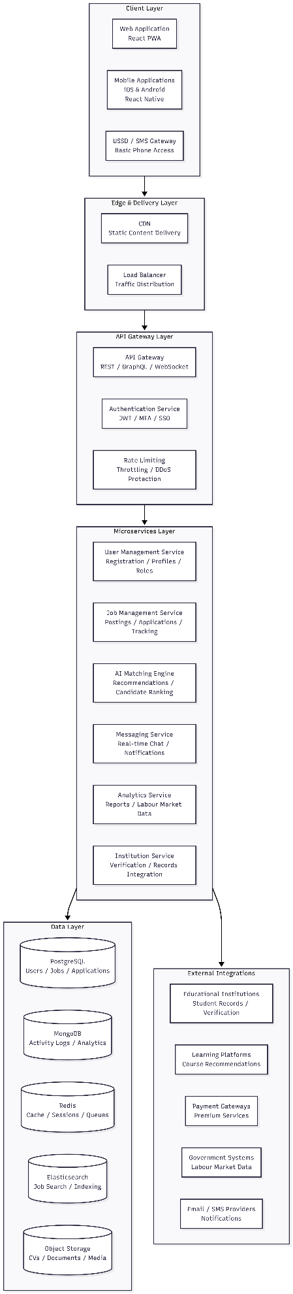
Architecture Component Description
Layer | Components | Description
Client Layer | Web Application, Mobile Apps, USSD Gateway | Provides multiple access points for users with varying device capabilities and connectivity levels. Mobile-first design ensures accessibility for users with limited bandwidth.
Edge & Delivery Layer | CDN, Load Balancer | Distributes traffic efficiently, caches static content for faster loading, and ensures high availability across geographic regions.
API Gateway Layer | API Gateway, Authentication, Rate Limiting | Serves as the single entry point for all client requests, handles authentication and authorization, and protects against abuse through rate limiting.
Microservices Layer | User, Job, AI Matching, Messaging, Analytics, Institution Services | Independent, scalable services that handle specific business functions. This modular approach enables independent development, deployment, and scaling of each service.
Data Layer | PostgreSQL, MongoDB, Redis, Elasticsearch, Object Storage | Multi-database architecture optimized for different data types: relational data, flexible activity logs, high-speed caching, powerful search capabilities, and file storage.
External Integrations | Educational Systems, Learning Platforms, Payment Gateways, Government Systems, Notification Providers | Connects with third-party systems to enrich platform functionality, verify credentials, provide learning resources, process payments, and deliver notifications.

14.9 Database Design
Database design involves organizing data into schemas to support efficient storage, retrieval, and management. This process includes defining relationships, keys, normalization levels, and indexing strategies to enhance data consistency and integrity.
Database architecture plays a key role in the Career Connect Lesotho platform's organization and management of the massive volumes of data produced by users, job postings, applications, and system interactions. Effective data storage is ensured by a well-structured database, which makes it possible to analyse and retrieve user profiles, job listings, application records, and analytics data quickly. Reducing redundancy, improving query efficiency, and guaranteeing data consistency are all made possible by proper normalization and indexing.
Furthermore, scalability is supported by a strong database design, which enables the system to manage growing data volumes as the platform expands. User access control and encryption are two examples of security measures that guarantee the protection of private user data, including personal information, academic records, and employment history. Additionally, this design makes it simple to integrate with other systems, such analytics tools, learning platforms, and payment gateways, guaranteeing smooth operations and improving system performance and dependability.

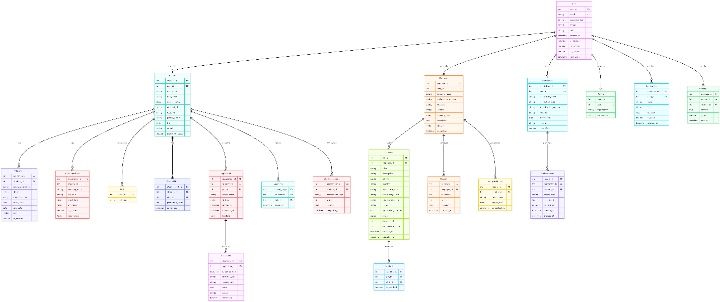

14.9.1 System Hardware Architecture

System hardware architecture refers to the physical layout of hardware components within a system, including servers, communication devices, and storage. The architecture determines how these components interact to support software functions and achieve operational goals.
The system hardware design for the Career Connect Lesotho platform specifies the actual parts needed for data processing, storage, and delivery. Cloud servers, database servers, load balancers, caching servers, storage systems, and networking infrastructure are all included in this. Data travels smoothly from users to the backend systems thanks to a carefully thought-out hardware architecture, enabling real-time job matching, application processing, and notification delivery.
Scalability depends on the hardware design, which establishes how the system will grow to accommodate additional users, job postings, and applications without sacrificing functionality. Additionally, it affects dependability by guaranteeing that crucial parts, such backup systems and redundant server clusters, are built to withstand faults. To further safeguard sensitive user data, security features like hardware security modules and encrypted storage can be incorporated into the architecture.
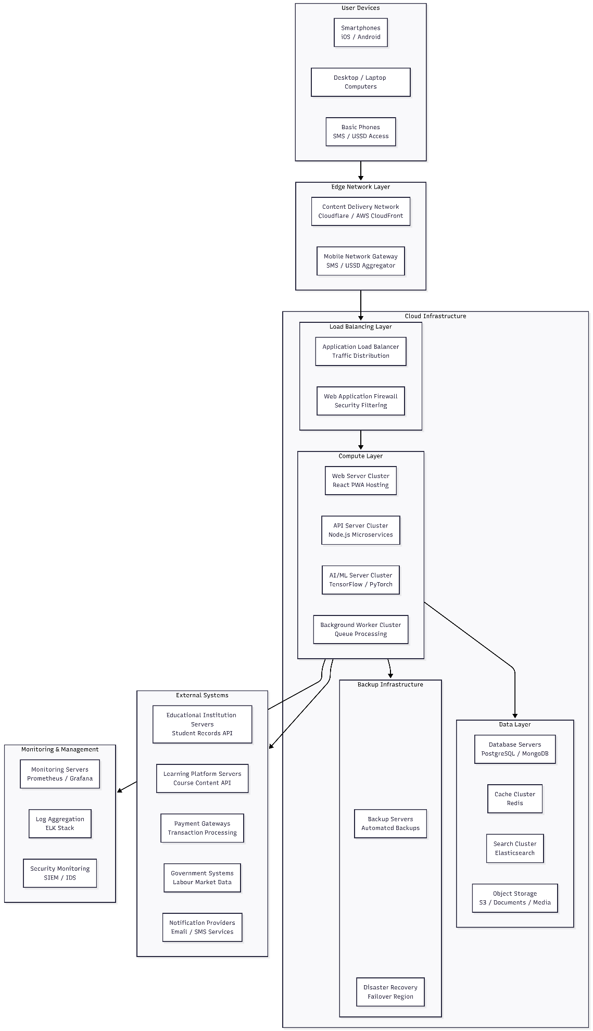

14.9.2 Interface Design

Interface design focuses on creating user-friendly, visually appealing, and efficient points of interaction between users and the system. Principles of usability and accessibility are central to its success.

The interface design of the Career Connect Lesotho platform guarantees that students, employers, institutions, administrators, and government users can communicate with the system with ease. The web and mobile app designs will make it easier for students to search for jobs, track applications, complete skills assessments, and communicate with employers. Accessibility will be enhanced by a simple, user-friendly design that makes it easy for users of various technical backgrounds to utilize the platform.

The interface will facilitate monitoring and management for administrators by offering real-time notifications and rapid access to user data, job postings, and system analytics. Interface design that prioritizes responsiveness and usability will guarantee that the system runs seamlessly on a variety of devices, from desktop computers to mobile phones with limited bandwidth, enhancing user experience and adoption in general. In the end, a well-designed interface boosts productivity, lowers errors, and helps the project reach important objectives like operational efficacy and user satisfaction.

Design Principles
Principle | Application
Simplicity | Clean, uncluttered interfaces with clear navigation paths; minimal steps to complete key tasks
Consistency | Uniform design patterns across web and mobile; consistent terminology and visual elements
Accessibility | WCAG 2.1 Level AA compliance; screen reader support; keyboard navigation; color contrast standards
Responsiveness | Seamless experience across desktop, tablet, and mobile devices; adaptive layouts for all screen sizes
Feedback | Clear system responses to user actions; loading indicators; success/error messages
Offline Support | Core functionality available without internet; automatic sync when connectivity restored
Localization | Full support for English and Sesotho; culturally appropriate imagery and content

